

GROUP ASSIGNMENT

TECHNOLOGY PARK MALAYSIA

CT077-3-2-DSTR

DATA STRUCTURE

APU2F2602CS (AI) / APD2F2602CS(AI)

HAND OUT DATE:

HAND IN DATE:

WEIGHTAGE: 50%

INSTRUCTIONS TO CANDIDATES:

- Students are advised to underpin their answers with the use of references (cited using the American Psychological Association (APA) Referencing).
- Late submission will be awarded zero (0) unless Extenuating Circumstances (EC) are upheld.
- Cases of plagiarism will be penalized.
- Submit the assignment to APU Learning Management System.
- You must obtain 50% overall to pass this module.

Group No: 18
Ian Chin Jun Sheng TP076218
Isac Lim Yong Hao TP076305
Lai Ker Jinn TP077827
Mohamed Muhlis TP077835
Soh Ye Wen TP078275

Table of Content
Table of Content 2
Table of Figure 4
1.0 Introduction 5
1.1 Objectives 5
1.2 Dataset Description 6
2.0 Theoretical Explanation 7
2.1 Array Implementation (kerjinn) 7
2.2 Singly Linked List Implementation (ian) 8
2.2.1 Node Structure 8
2.2.2 Implementation of Datasets 10
2.3 Sorting Experiments 12
2.4 Searching Experiments 12
3.0 Input and Output 13
4.0 Individual Part 14
4.1 Ian Chin Jun Sheng 14
4.1.1 Responsibilities and Contribution 14
4.1.2 Functions / Components Developed 14
4.1.3 Implementation Decisions 14
4.1.4 Analysis 14
4.2 Isac Lim Yong Hao 14
4.2.1 Responsibilities and Contribution 14
4.2.2 Functions / Components Developed 14
4.2.3 Implementation Decisions 14
4.2.4 Analysis 14
4.3 Lai Kerjinn 15
4.3.1 Responsibilities and Contribution 15
4.3.2 Functions / Components Developed 15
4.3.3 Implementation Decisions 15
4.3.4 Analysis 15
4.4 Mohamed Muhlis 15
4.4.1 Responsibilities and Contribution 15
4.4.2 Functions / Components Developed 15
4.4.3 Implementation Decisions 15
4.4.4 Analysis 15
4.5 Soh Ye Wen 15
4.5.1 Responsibilities and Contribution 15
4.5.2 Functions / Components Developed 15
4.5.3 Implementation Decisions 15
4.5.4 Analysis 15
5. Experimental Results and Overall Comparative Analysis 16
5.1 Overall Sorting Comparison 16
5.2 Overall Searching Comparison 16
5.3 Performance Analysis 16
5.3.1 Execution Time Analysis 16
5.3.2 Memory Footprint Analysis 16
5.3.3 Conditions Where Each Structure Performs Better 16
5.3.4 Real-World Advantages and Trade-offs 16
5.4 Overall Array vs Linked List Findings 16
5.5 Strengths and Limitations 16
6. Clinical Insights and Recommendations 16
6.1 Treatment Cost and Service Preference Analysis 16
6.2 Highest Healthcare Billing by Demographic Group 16
6.3 Highest Patient Traffic by Care Type 16
6.4 Recommendations for Hospital Administrators 16
7.0 Conclusion 16
References 17
Workload Matrix 17
Appendix 17

Table of Figure
Figure 1: Dataset 1 facility A 6
Figure 2: Dataset 2 facility B 6
Figure 3: Dataset 2 facility C 7
Figure 4: patient_list.hpp - Node struct and start of the PatientList class 8
Figure 5: dataset.hpp - the Patient struct 8
Figure 6: patient_list.hpp - the private head_, tail_ and size_ members 9
Figure 7: patient_list.cpp - PatientList::append() 9
Figure 8: report.cpp - analyse(), one head-to-tail traversal building every total and average 10
Figure 9: patient_list.cpp - PatientList::clear() 10
Figure 10: Dataset facility a 10
Figure 11: main.cpp - DATASET_COUNT and LIST_COUNT 11
Figure 12: main.cpp - loadAll() 11
Figure 13: main.cpp - running analyse () 12
Figure 14: Age group legend - singly linked list 13
Figure 15: Browse Records output for Dataset 1 - Facility A, first 10 of 200 records 13

1.0 Introduction
The purpose of this assignment is to develop and experiment with data structures (arrays and singly linked lists) based on healthcare datasets and analyze their implementation. Demographic, type of care, length of visit and billing data for patients is stored in three datasets, corresponding to three different healthcare institutions. The project presents some example applications of such data structures to efficiently organize and access healthcare records.
The project also explores the data by sorting, searching, categorisation, demographic analysis and health expenditure analysis. The execution times, number of comparisons and memory requirement are compared between arrays and singly linked lists. Data collected is then analysed to analyse the trends in healthcare and to give certain practical ideas to the management of healthcare services.

1.1 Objectives
- Create three datasets for healthcare using arrays & singly linked list.
- To classify their patients in the given age groups and study their attitude toward health care facilities.
- To determine the overall and average spending per care type, by age group.
- To use sorting and searching for both data structures.
- To make a comparison between execution time, comparisons, and memory usages in arrays and singly linked list.

1.2 Dataset Description
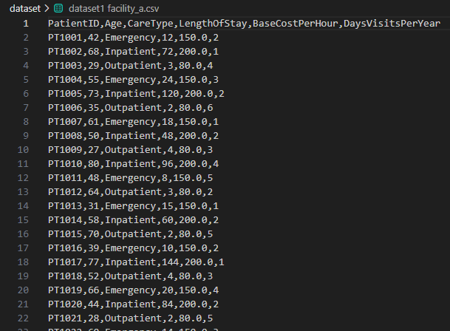
Figure 1: Dataset 1 facility A
Dataset 1 is a General hospital with Emergency, Surgical and Out Patient Cares. It mainly consists of adult and elderly patients. The dataset is analyzed for patient demographics and patient visits' duration and medical spending.
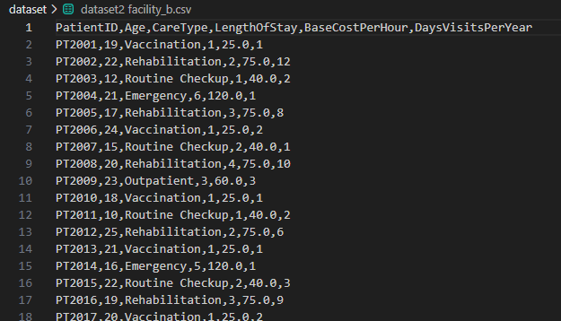
Figure 2: Dataset 2 facility B
The dataset 2 refers to a university medical centre, and primarily deals with young patients and university students. Services available are: Rehabilitation, Vaccination, and Preventive Care. This data can be used to analyze patient preference and costs for younger patient populations.
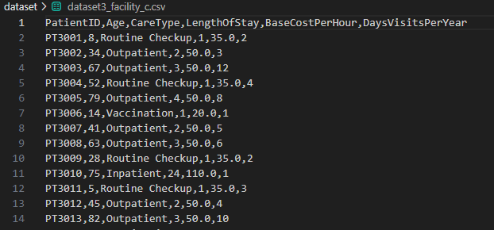
Figure 3: Dataset 2 facility C
The community health clinic outlined in Dataset 3 provides services to people over a variety of ages. It offers primarily General Consultation and Chronic Care. The data set additionally gives a wider dispersion of demographics and can be used to compare the demand and expenditure on health care by age group.

2.0 Theoretical Explanation

2.1 Array Implementation (kerjinn)

2.2 Singly Linked List Implementation (ian)

2.2.1 Node Structure
Each patient record is in a node. Every node stores two things: patient's data and the address of the next node. The list keeps a head pointer to the first node. The end of the list is denoted by having a NULL (nullptr) next node.
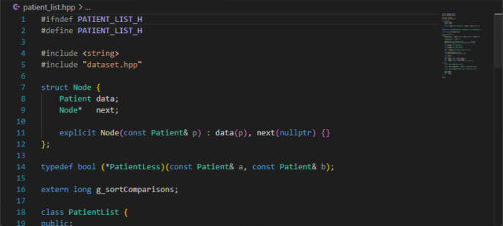
Figure 4: patient_list.hpp - Node struct and start of the PatientList class
Node: Each element of the list is called a Node. The list expands as a record is added to the heap using new and never has to be fixed length or resized, unlike an array.
Data: The data field is a struct of patients. It holds the six CSV columns plus two fields worked out when the record is loaded:
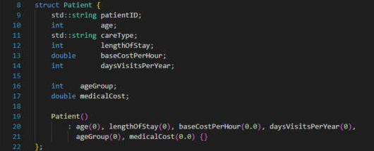
Figure 5: dataset.hpp - the Patient struct
Next pointer: contains the address of the next node. List is singly linked as each node only has a next pointer and no prev pointer. The constructor is defining next to nullptr, so it is always a valid end of the list.
Head pointer: The chain is owned by PatientList and the only point to get into the list is through head_. It also keeps a tail_ pointer and a size_ counter:
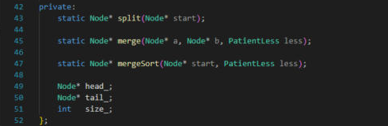
Figure 6: patient_list.hpp - the private head_, tail_ and size_ members
Insertion at the end is O(1) thanks to tail_. If it wasn't, each append would have to traverse the entire list in order to find it.
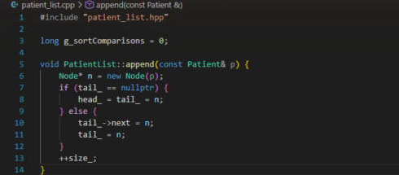
Figure 7: patient_list.cpp - PatientList::append()
Copy constructor and copy assignment are deleted (or omitted). Thus, two lists must never have the same nodes; otherwise, they would result in a double delete.
Traversal. The pattern is used to build each total in analyse() in report.cpp, and to compute the average for the program, just a single pass through each list.
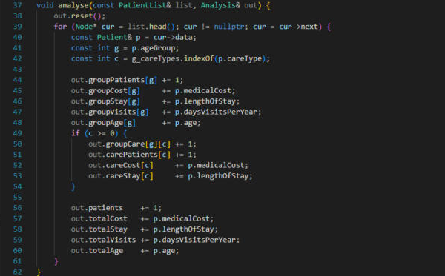
Figure 8: report.cpp - analyse(), one head-to-tail traversal building every total and average
The destructor calls clear(), which is also called at the end of the list. It saves next before deleting each node, since if a node is deleted, then next field cannot be read again:
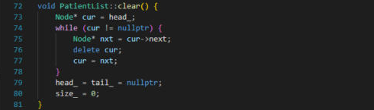
Figure 9: patient_list.cpp - PatientList::clear()

2.2.2 Implementation of Datasets
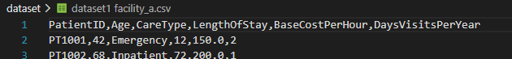
Figure 10: Dataset facility a
Table 1:three input dataset tables
Dataset | File | ID range
Dataset 1, Facility A | dataset/dataset1 facility_a.csv | PT1001 to PT1200
Dataset 2, Facility B | dataset/dataset2 facility_b.csv | PT2001 to PT2200
Dataset 3, Facility C | dataset/dataset3_facility_c.csv | PT3001 to PT3200
There are four PatientList objects declared in the main() function. The first three indexes (0-2) store the three facilities, the last one (3) stores all three combined.
Figure 11: main.cpp - DATASET_COUNT and LIST_COUNT
Loading by using loadCSV() will read the file line by line. It creates a Patient, calls categoriseAndBill() for each row to calculate the derived fields and then adds the record to the list. Rows with the incorrect number of columns, fill in non-numeric data or incorrect data (e.g. negative age, zero stay, rate or visits) are considered skipped and will not be added to the list:
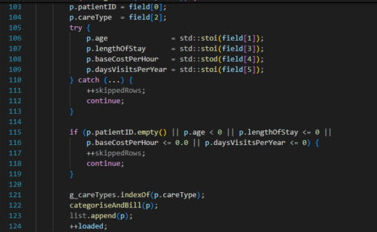
Creating the merged list. Once a facility is loaded, loadAll() goes through the list and adds a duplicate of each record to lists[3]. The combined list has its own nodes, and it is freeing one list that will never have an impact on another:
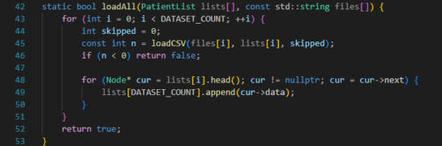
Figure 12: main.cpp - loadAll()
Combined list contains Facility A, B, and C, as append does not shuffle the order.

Analysis. Once through the analyse () process, each list is followed by one analysis() process and then a corresponding Analysis struct is stored. These precompute results are used to read all the menu options:
Figure 13: main.cpp - running analyse ()
Under Section 3.0 Input and Output, the full console output of the Browse Records option is included, indicating that all 200 records from each file passed the validation test and that the total list contains 600 records (3 x 200). The Cost (RM) column checks out against the formula: PT1001 is 12 x 150.00 x 2 = 3600.00.

2.3 Sorting Experiments

2.3.1 Array

2.3.1.1 Merge Sort

2.3.1.2 Insertion Sort

2.3.2 Linked List
The sorting experiment for the singly linked list is run on Facility A, Facility B, Facility C and the combined list. Each list is sorted by Age, Length of Stay and Total Cost using merge sort and insertion sort. Before every run the list is put back into patient ID order, so both sorts start from the same data as the array version. For each run the program records the number of comparisons, the number of moves (pointer relinks), the time taken and the memory used.
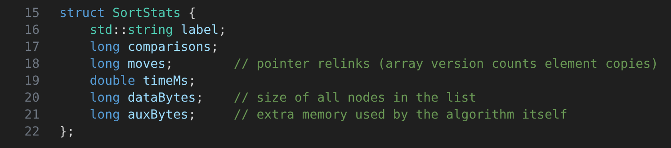
Figure 14: sort_search.hpp – SortStats struct
Recording the results. SortStats keeps the result of one sorting run. Besides comparisons and time, it has moves, which counts how many next pointers were changed, dataBytes, which is the size of all the nodes in the list, and auxBytes, which is the extra memory the algorithm itself needs. These fields follow the columns of the array version so the two programs can be compared directly.

2.3.2.1 Merge Sort
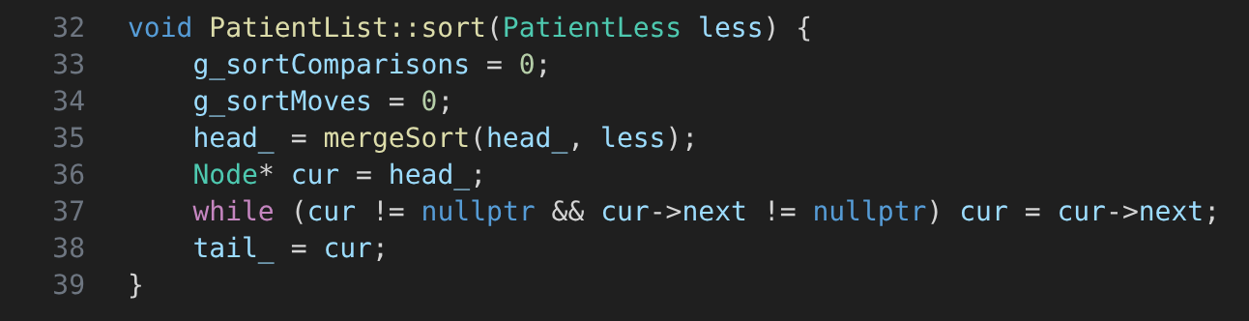
Figure 15: patient_list.cpp – PatientList::sort()
Starting the sort. sort() resets the comparison and move counters to 0, calls mergeSort() on the head node and then walks to the last node, so that tail_ points to the correct node after sorting.
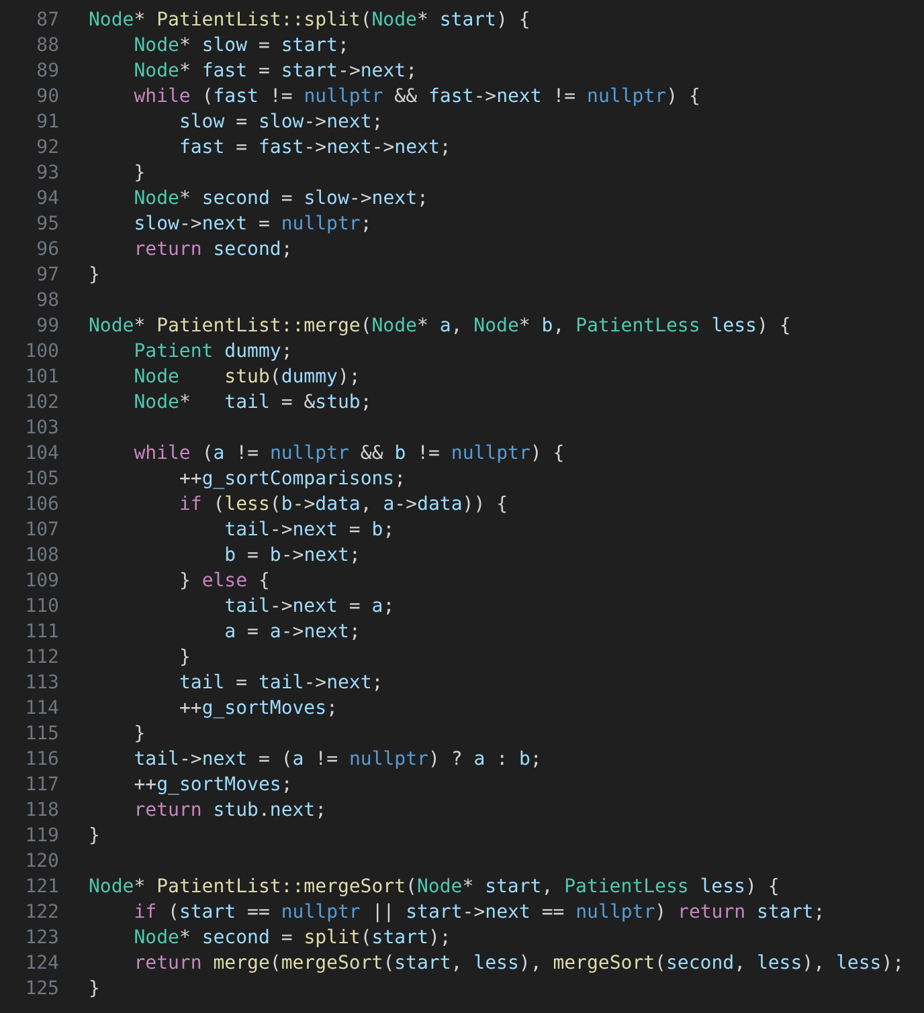
Figure 16: patient_list.cpp – split(), merge() and mergeSort()
Splitting. A linked list cannot jump to its middle, so split() uses two pointers. The fast pointer moves two nodes each time the slow pointer moves one. When the fast pointer reaches the end, the slow pointer is at the middle and the list is cut there.
Merging. merge() compares the first node of each half and links the smaller one to the result, using a dummy stub node as the starting point. Each comparison adds 1 to g_sortComparisons and each link adds 1 to g_sortMoves. mergeSort() keeps splitting the list until every part has one node, then merges them back in order. Only the next pointers change, so no patient record is copied.
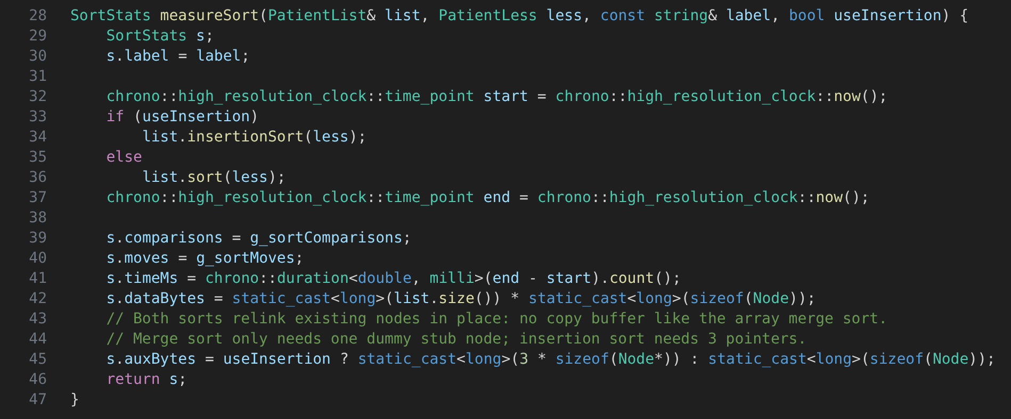
Figure 17: sort_search.cpp – measureSort()
Measuring. measureSort() runs either merge sort or insertion sort and times it with chrono. It then saves the comparisons and moves from the counters, the data size as the number of nodes times the size of one node, and the extra memory. Merge sort only needs one stub node (112 bytes), while insertion sort only needs three pointers (24 bytes), because both sorts relink the existing nodes instead of using a copy buffer like the array merge sort.
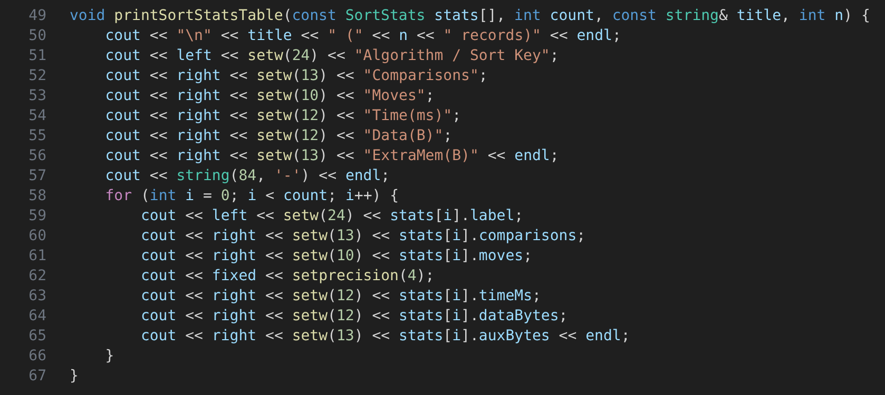
Figure 18: sort_search.cpp – printSortStatsTable()
Results table. printSortStatsTable() prints the results of the six runs as a text table in the console, with the algorithm and sort key, comparisons, moves, time, data size and extra memory on each row.
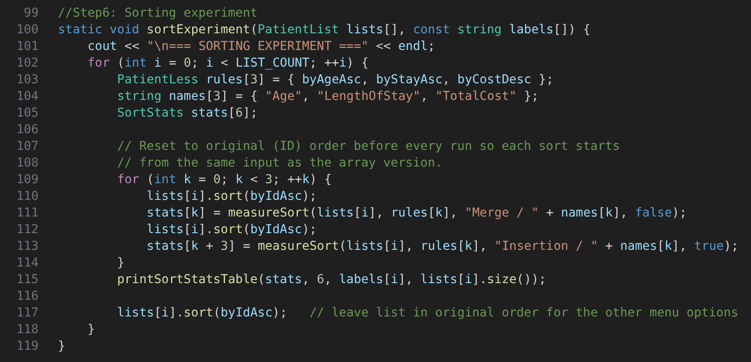
Figure 19: main.cpp – sortExperiment()
Running the experiment. sortExperiment() goes through the four lists and, for each sort key, puts the list back into patient ID order before running merge sort, then does the same again for insertion sort. After the table is printed, the list is sorted by ID again so the other menu options still see the original order.

2.3.2.2 Insertion Sort
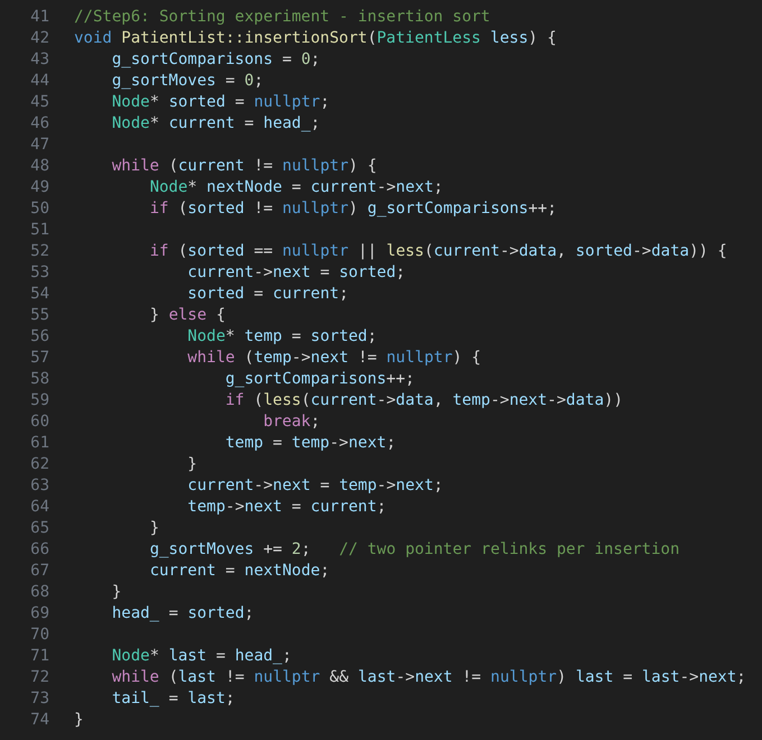
Figure 20: patient_list.cpp – PatientList::insertionSort()
Insertion sort builds a new sorted list by taking one node at a time from the original list and linking it into the right place. The next node is saved first, because current->next changes once the node is moved. If the node is smaller than the first sorted node it becomes the new head, otherwise the sorted list is walked until the correct position is found. Every insertion only changes two pointers, so the moves are always 2 per node (400 for 200 records). The weakness is the comparisons, because each new node may be compared with many nodes that are already sorted, which makes insertion sort O(n²).

2.4 Searching Experiments
The searching module finds patient records that meet the user’s criteria. The three criteria are represented by a SearchCriteria structure: age (61–100), care type (Emergency), and length of stay (more than 24 hours). All the criteria can be combined, and one function, matchesCriteria() in the array version and SearchCriteria::matches() in the linked list version, checks whether a certain patient record meets the criteria. For each experiment, the number of comparisons, the time (ms) taken for processing the query, the number of matches found, and the extra memory consumed by the result set were recorded. One comparison is when a record or a node is accessed and checked. Two queries were executed for each of the facilities A, B, and C, as well as the combined data set: Query A: Age 61–100 and Care Type = Emergency and Query B: Length of Stay > 24 hours
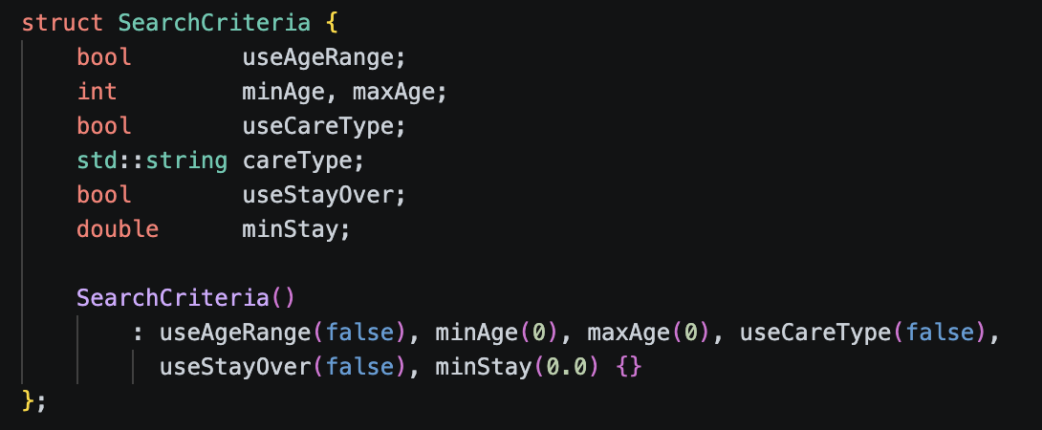
Figure 21：SearchCriteria Code

2.4.1 Array
Linear search on unsorted data (linearSearch). The array is scanned from index 0 to n−1 and all matching records are copied to an allocated result array. Since all matches must be found, the scanning cannot be halted after the first hit. Time complexity is O(n) and extra space allocation is O(k) for k matches.
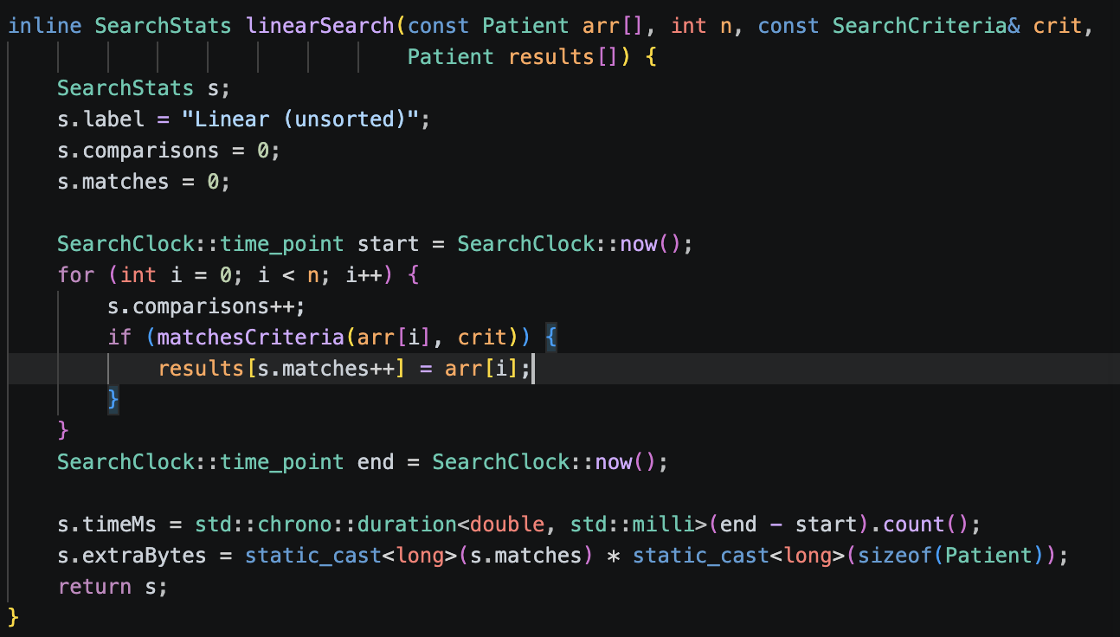
Figure 22: linear Search Function
Binary boundary search (binaryFirstGreater). On an array that is already sorted by a key (age or length of stay), the function performs a binary search to find the first index whose key is greater than a threshold. It runs in O(log n) and the number of matches for a "greater than" query is simply n − index. The midpoint is calculated as low + (high - low) / 2 to avoid integer overflow. A function pointer (ageOf or stayOf) is used to select which field is the key, so that one function can serve for both fields.
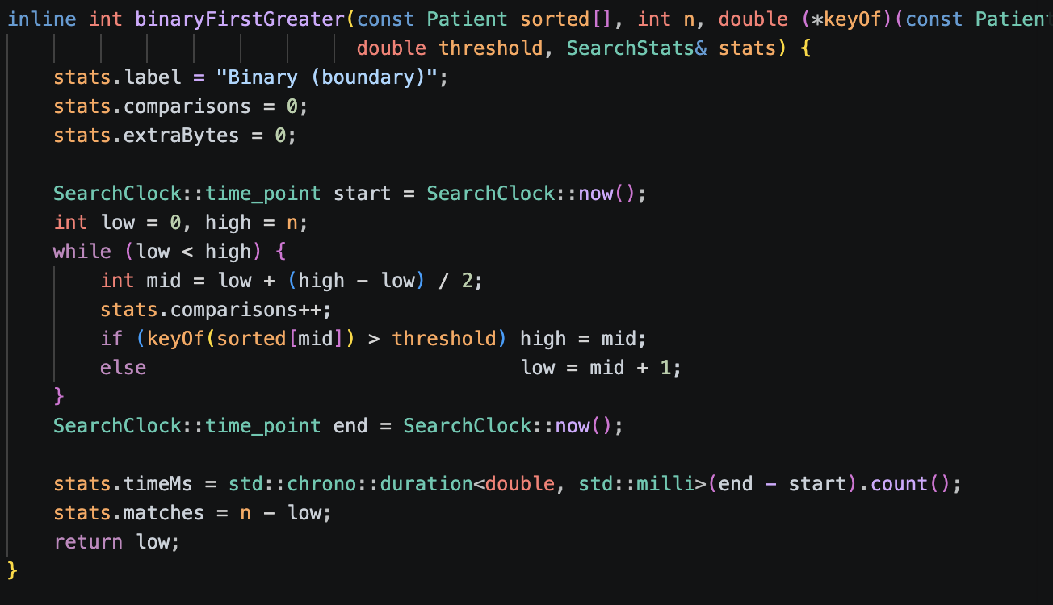
Figure 23: binaryFirstGreater Function
Range search on sorted data (rangeSearchSortedByAge). This is a combination of the above two searches: a binary search to find the first patient with age ≥ a lower bound, followed by scanning the array to collect the records until the age exceeds an upper bound. The care type is filtered during the scanning since the array is sorted by age and not by a care type. Time complexity is O(log n + m), where m is the number of the records inside the range.
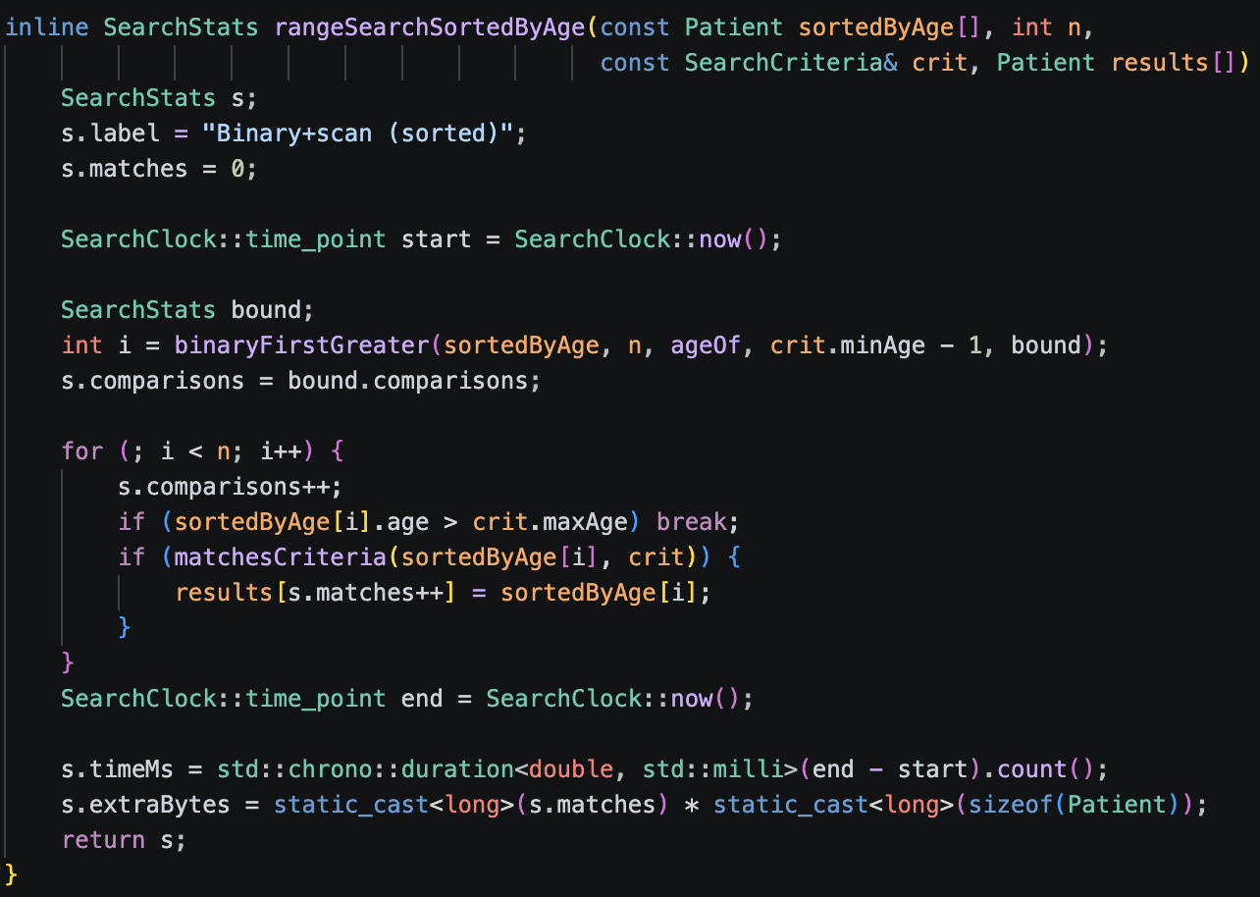
Figure 24: rangeSearchSortedByAge Function
Exact binary search (binarySearchByKey). This is a standard binary search to find a single record having a certain key (e.g., age 65 is used as a demo value here). It stops at the first hit. It runs in O(log n) and returns at most 1 record.
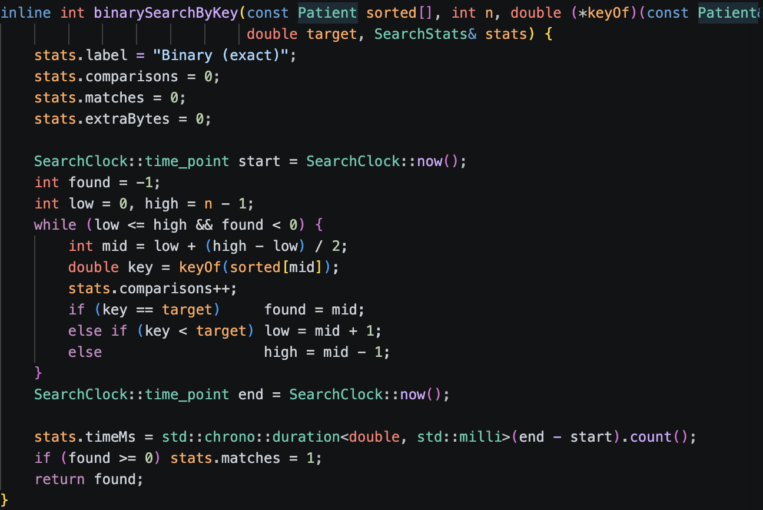
Figure 25: binarySearchByKey Function
The sorted copy for the searches is created using the merge sort implemented in Sortinganalysis.hpp. The time complexity of the sorting is not included in the reported search time.

2.4.2 Linked List
The searching experiment for the linked list uses the same two queries as the array program. The senior emergency search looks for patients aged 61 to 100 with the care type Emergency, and the long stay search looks for patients who stayed more than 24 hours. Each query is done with linear search on the unsorted list and with binary search on a list sorted by the search key. Besides comparisons, time, matches and extra memory, the linked list also records node hops, which are the steps needed to walk from the head to a node.
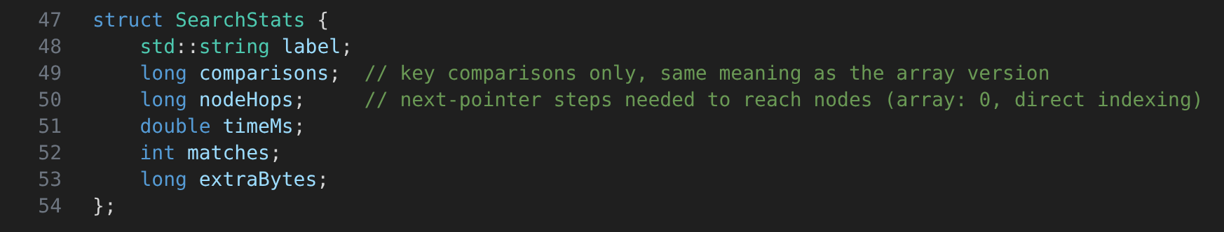
Figure 26: sort_search.hpp – SearchStats struct
Recording the results. SearchStats keeps the result of one search. comparisons only counts key comparisons, so it means the same thing as in the array version. nodeHops is new for the linked list: it counts how many times the program follows a next pointer to reach a node. In an array this is always 0 because any element can be reached directly by its index.

2.4.2.1 Linear Search
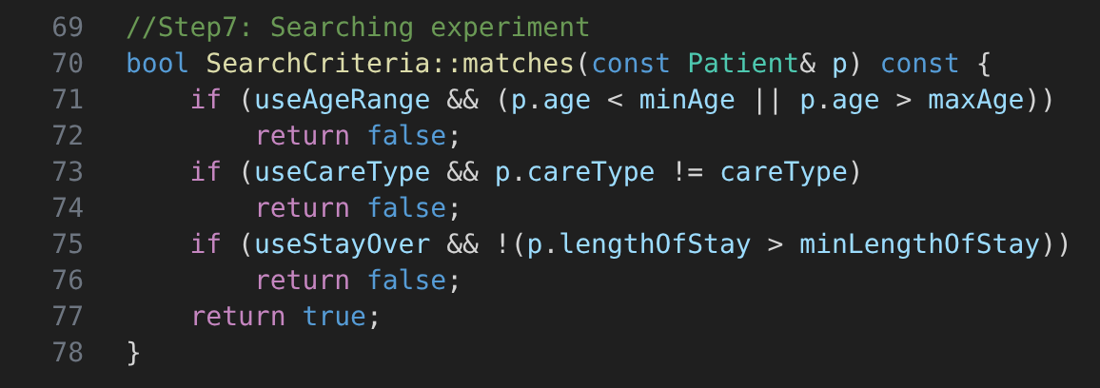
Figure 27: sort_search.cpp – SearchCriteria::matches()
Matching. matches() checks one patient against the criteria that are turned on. It returns false as soon as one criterion fails, so a patient only matches when every active criterion passes. Both queries and both kinds of search use this same function.
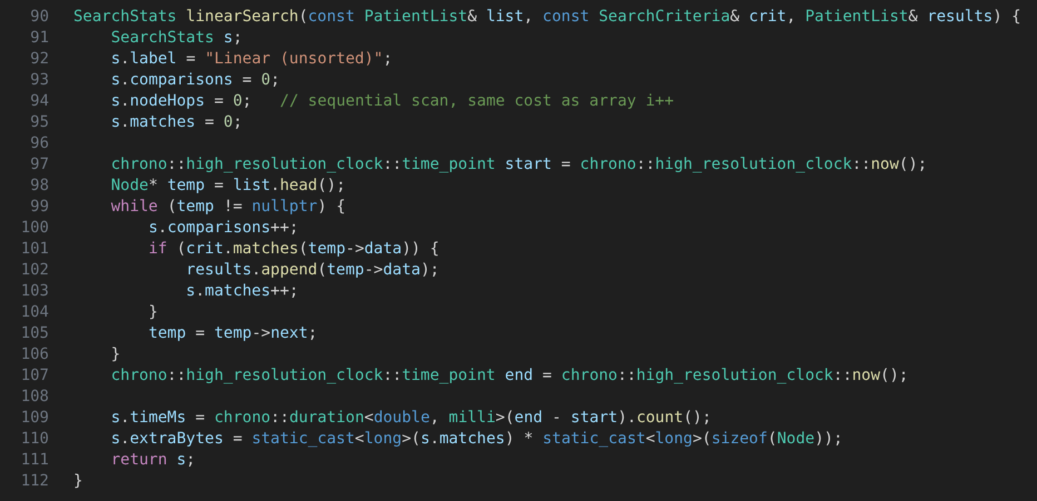
Figure 28: sort_search.cpp – linearSearch()
Linear search on the unsorted list. linearSearch() starts at the head and visits every node until the end, adding one comparison per node. A matching patient is appended to a results list. Node hops stay at 0 because moving to the next node is part of the normal scan, the same as i++ in the array. The extra memory is the results list, which is the number of matches times the size of one node. The time complexity is O(n).

2.4.2.2 Binary Search
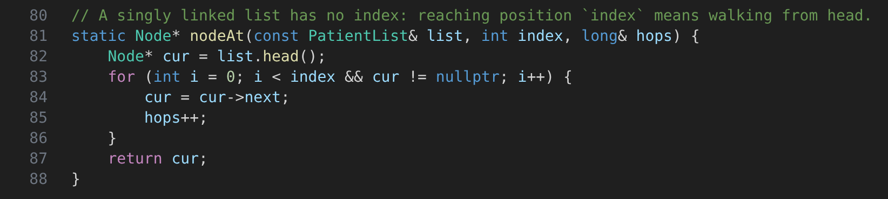
Figure 29: sort_search.cpp – nodeAt()
Reaching a position. A linked list has no index, so nodeAt() walks from the head to the wanted position and adds every step to the node hops. This is what makes binary search on a linked list expensive, since each middle point can cost up to n steps to reach.
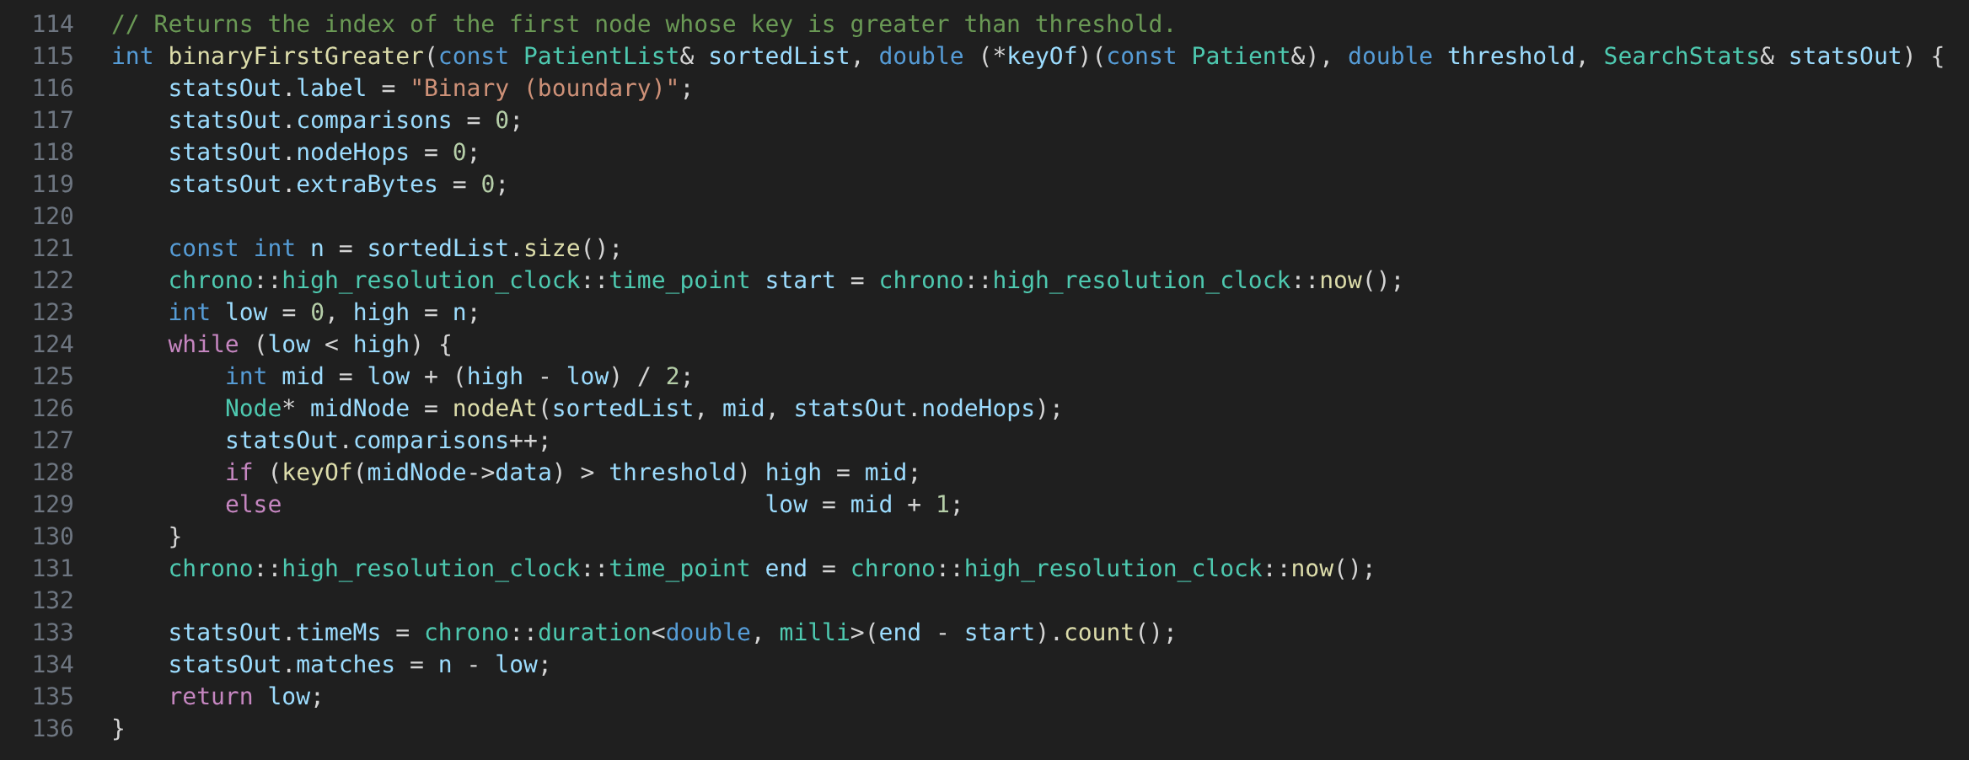
Figure 30: sort_search.cpp – binaryFirstGreater()
Binary boundary search. binaryFirstGreater() is used on a list sorted by length of stay. It finds the first node whose key is greater than the threshold (24 hours). Everything from that position to the end of the list matches, so the number of matches is n minus the boundary index. It only needs about log n comparisons, but every middle point is reached through nodeAt().
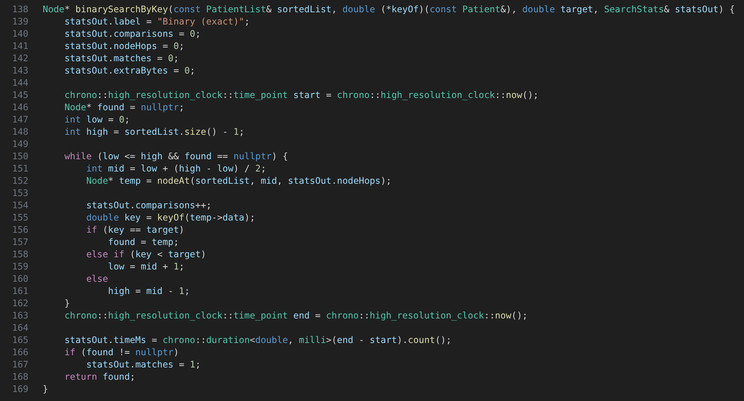
Figure 31: sort_search.cpp – binarySearchByKey()
Exact binary search. binarySearchByKey() looks for one patient with an exact key, in this case age 65. It checks the middle node, then keeps the lower or upper half until the patient is found or the range is empty, and returns at most one record.
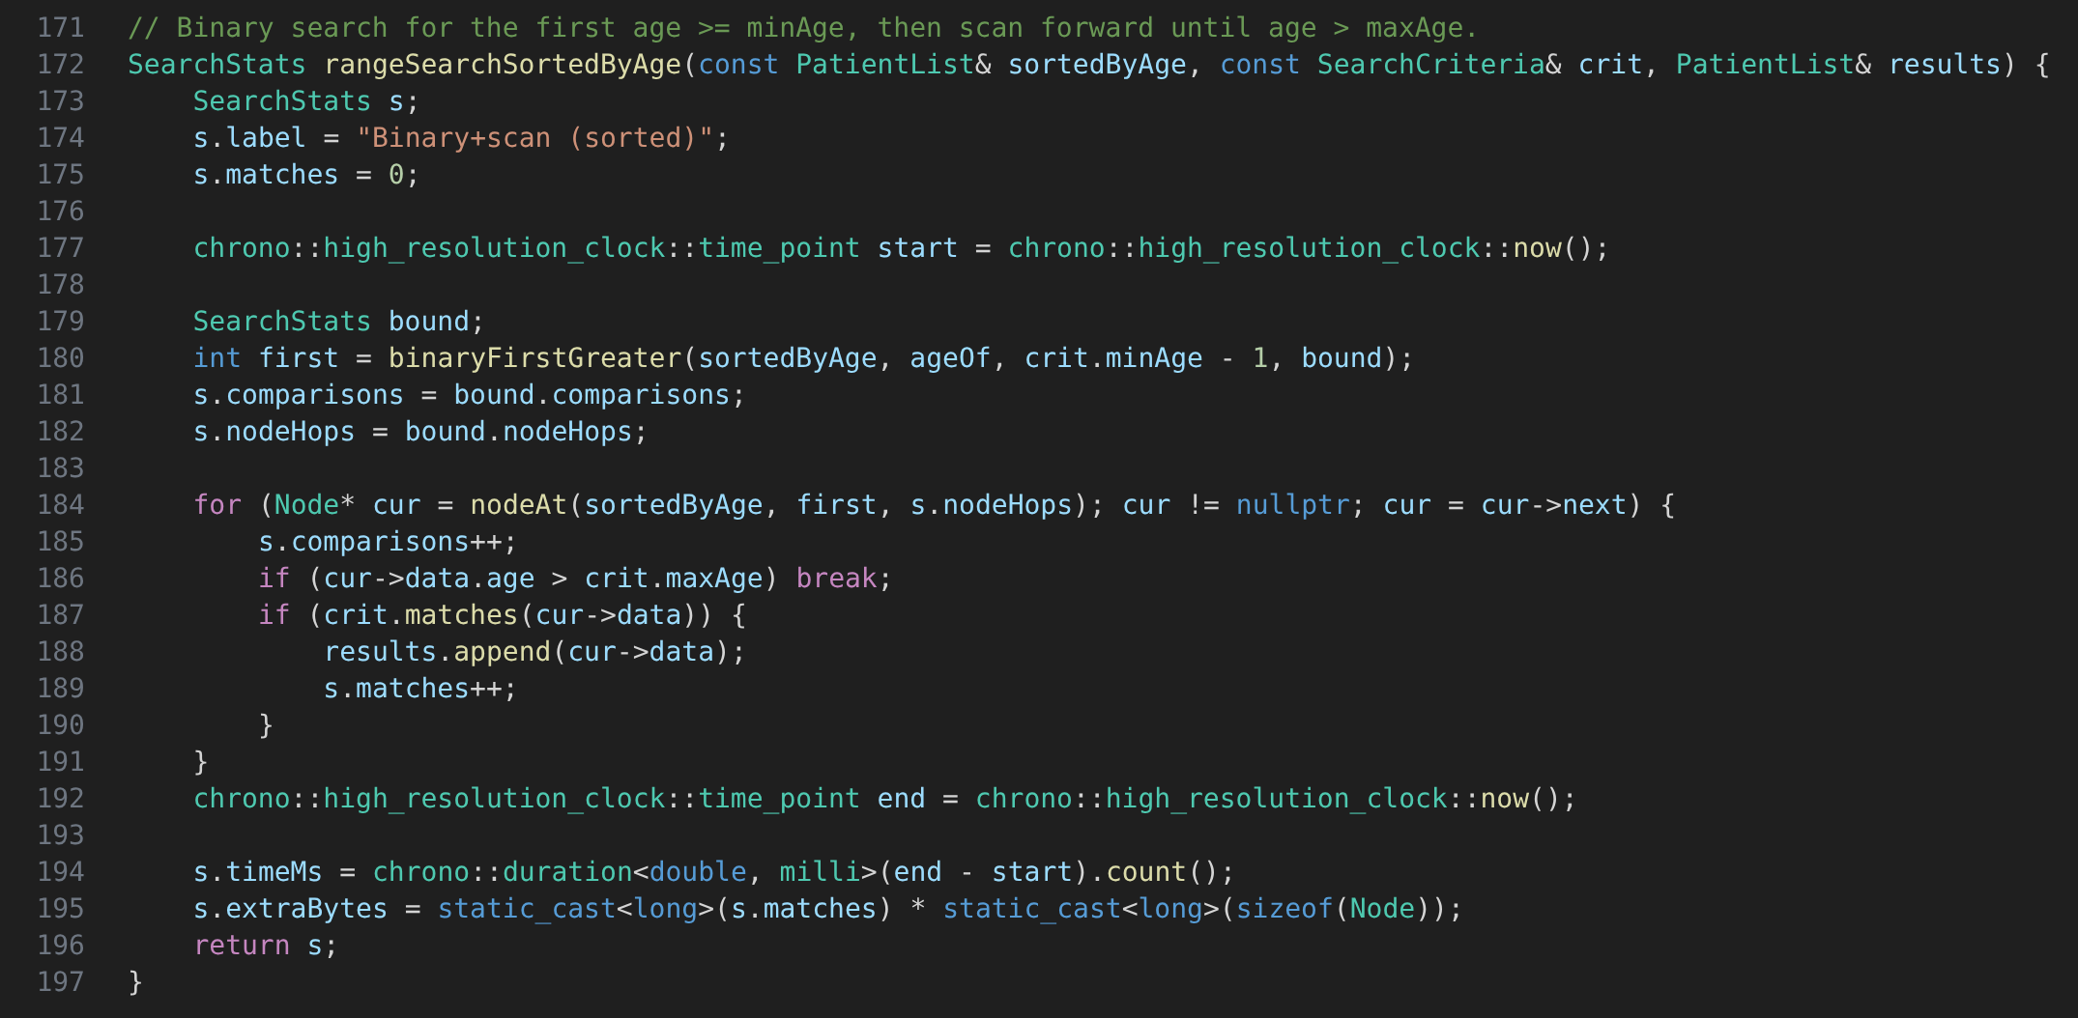
Figure 32: sort_search.cpp – rangeSearchSortedByAge()
Range search on sorted data. rangeSearchSortedByAge() first uses binaryFirstGreater() to find the first patient aged 61 or above, then scans forward from there and stops as soon as the age goes over 100. Inside the range, matches() is still used to check the care type. This way only the nodes inside the age range are checked instead of the whole list.
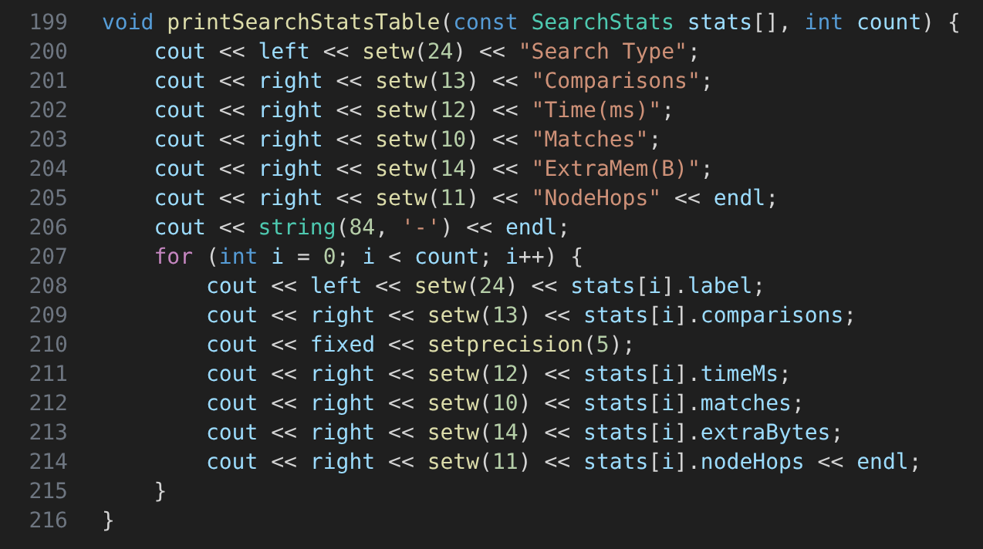
Figure 33: sort_search.cpp – printSearchStatsTable()
Results table. printSearchStatsTable() prints each search type with its comparisons, time, matches, extra memory and node hops in one table.
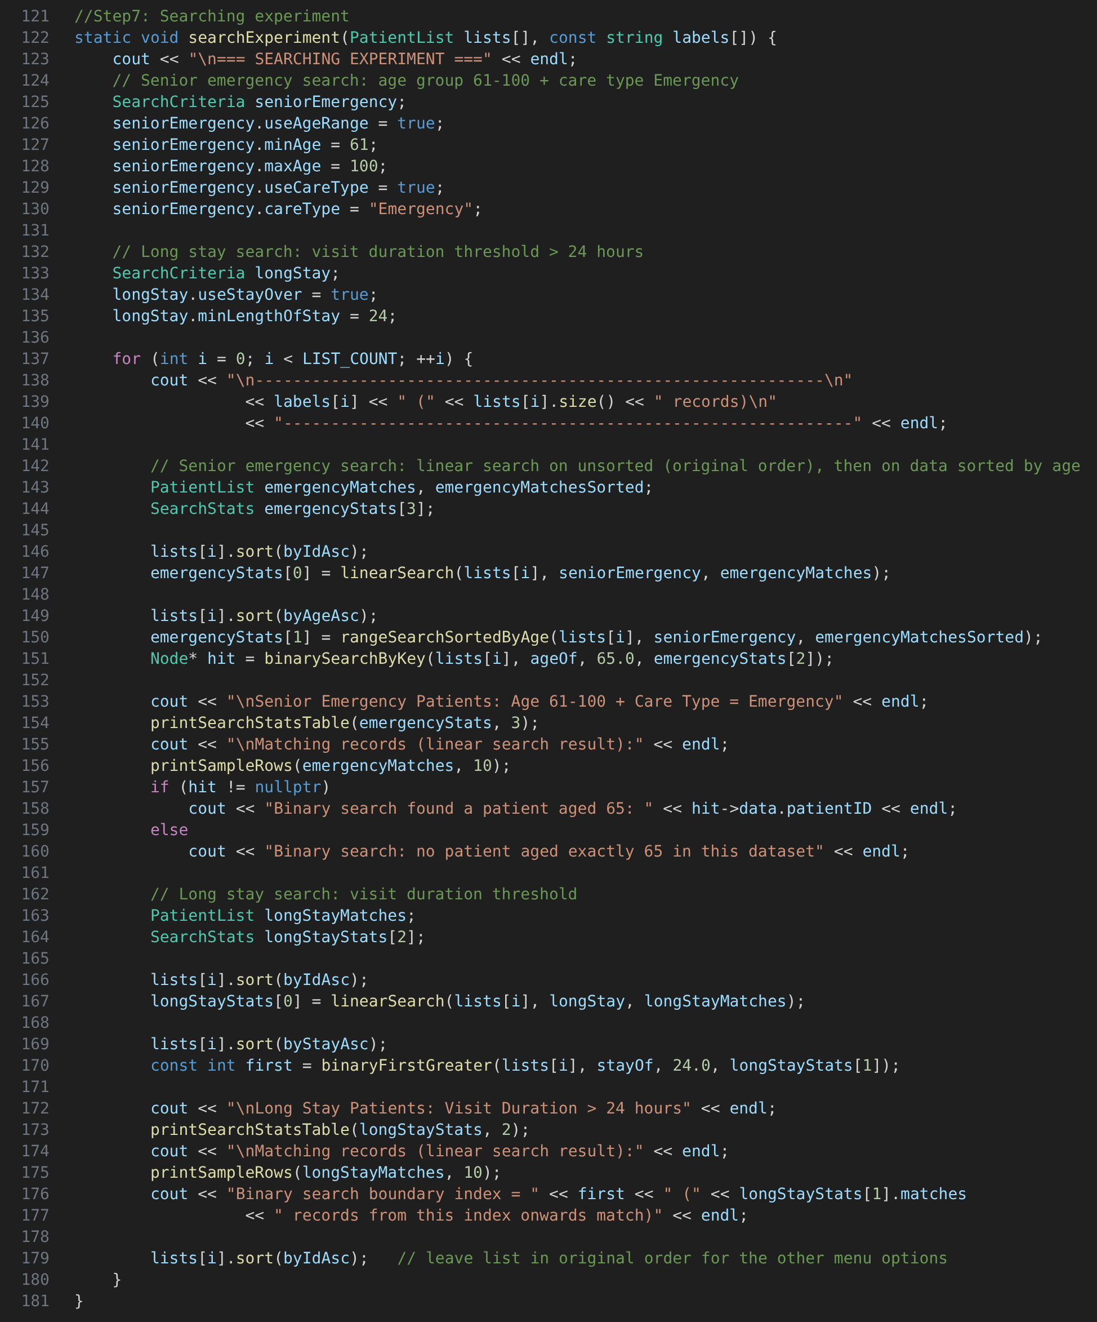
Figure 34: main.cpp – searchExperiment()
Running the experiment. searchExperiment() sets up the two queries and runs them on all four lists. For the senior emergency search, linear search runs on the list in patient ID order, then the list is sorted by age for the range search and the exact search for age 65. For the long stay search, linear search runs on the ID order again, then the list is sorted by length of stay for the boundary search. The sorting time is not counted in the search time, and at the end the list is put back into patient ID order.

3.0 Input and Output

3.1 Singly Linked List
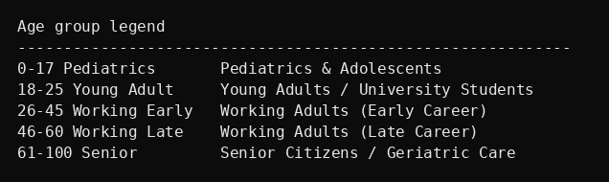
Figure 35: Age group legend - singly linked list

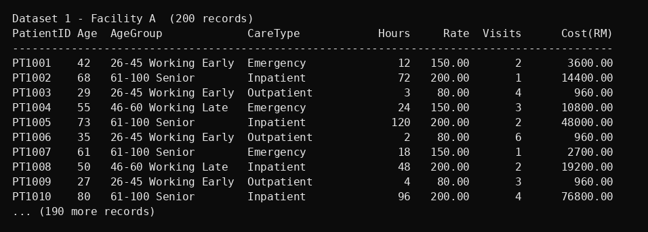
Figure 36: Browse Records output for Dataset 1 - Facility A, first 10 of 200 records
Running the experiment. This will search for ages 61-100 and a care type of Emergency. In each list the linear search is performed on the unsorted data first. It is then sorted by age using merge sort and binary search is used for the age 65. The two results are displayed in the table, and the matching patients are displayed following the table.

3.2 Sorting

3.2.1 Array
The array program performs the sorting experiment on Facility A, Facility B, Facility C and the combined dataset. Both merge sort and insertion sort are applied to the array and each one of them is run onthe three sort keys: Age, Length of Stay and Total Cost. For every runthe algorithm sorts a newly created copy of the original array in order to begin from the same order of data. The program then prints the number of comparisons, the running time and the estimated memory of the array for each run.
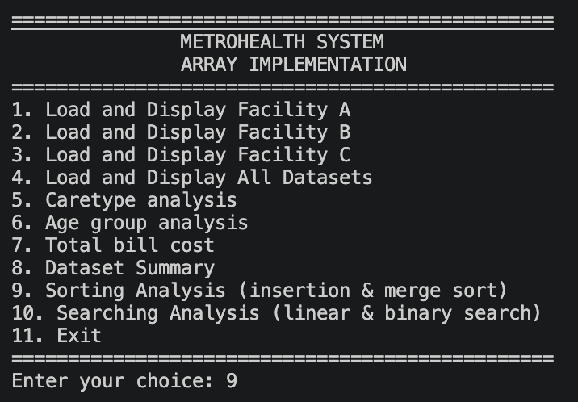
Figure 37: Array List Menu INPUT
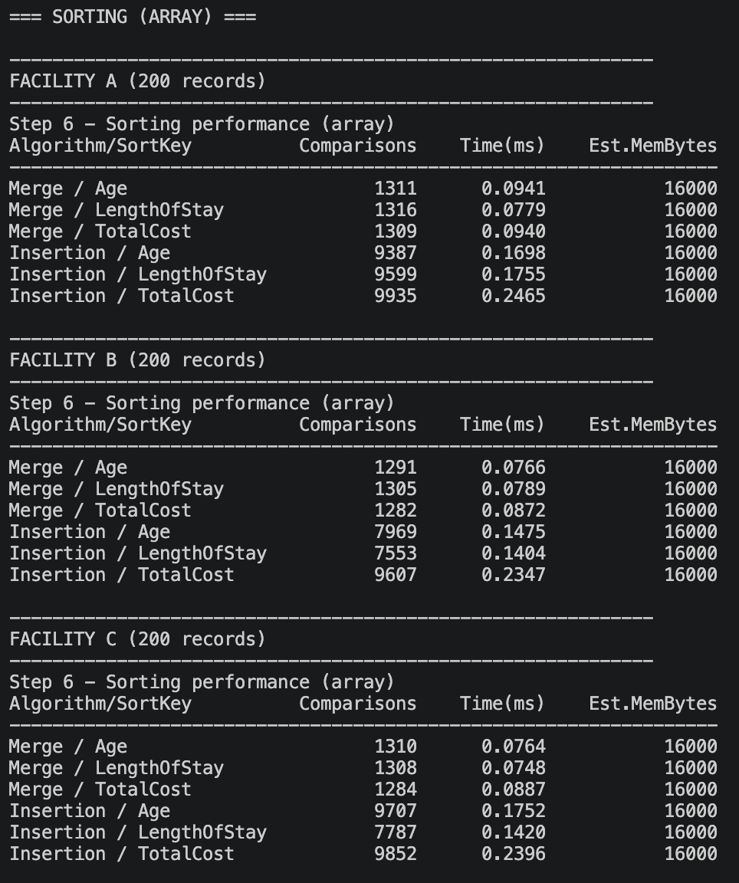
Figure 38: Array Performance Results OUTPUT
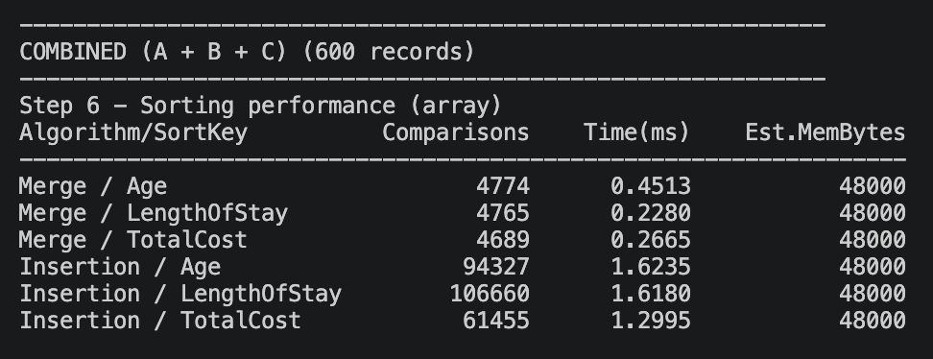
Figure 39: Array Sorting Performance Results on Combined Dataset – OUTPUT

3.2.1.1 Merge Sort
According to Figure 30, merge sort required 1,282-1,316 comparisons at each facility having 200 records, and each run was performed in 0.075-0.094 ms. The count of comparison turns out almost identical for each of the three sort keys since merge sort constantly divides the array into two, regardless of the order of elements. The estimated memory equals 16,000 bytes (200 records × 80 bytes), which is the size of the array. Merge sort also needs to allocate a temporary array of the same size during merging; thus, the peak memory consumption is about twice this figure.
For the combined array of 600 records (Figure 31), merge sort required 4,689-4,774 comparisons and 0.228-0.451 ms. Thus, when the data size was tripled, the comparisons increased by about 3.6 times, which fits with the theoretical complexity of O(n log n). The running time grew by about 2.8-4.8 times. A higher value was obtained for the Age run since it was the first run for the combined set and probably slowed down by a cold cache. Finally, the estimated memory increases to 48,000 bytes (600 × 80 bytes) due to the tripled number of records.

3.2.1.2 Insertion Sort
At each facility, insertion sort required 7,553-9,935 comparisons, which is about 6 to 8 times higher than merge sort, and 0.140-0.247 ms. The count depends on the sort key as insertion sort is sensitive to the initial order of elements. For instance, Facility B required 7,553 comparisons for the Length of Stay while 9,607 comparisons for the Total Cost. The extra memory is only a temporary record (the key being inserted) as elements are shifted within the same array. The estimated memory is therefore 16,000 bytes.
On the combined dataset, insertion sort required 61,455-106,660 comparisons and 1.30-1.62 ms as shown in Figure 31. Merge sort required about 13 to 22 times fewer comparisons and 3.6 to 7.1 times less time. As the array size was tripled, the comparisons increased by about 6 to 13 times, close to the 9 times expected from the O(n2) growth of insertion sort. Therefore, merge sort is the preferred option as the number of records increases.

3.2.2 Linked List
Option 7 of the linked list program runs the sorting experiment on Facility A, Facility B, Facility C and the combined dataset. Merge sort and insertion sort are run on each list by Age, Length of Stay and Total Cost, and the list is put back into patient ID order before each run.
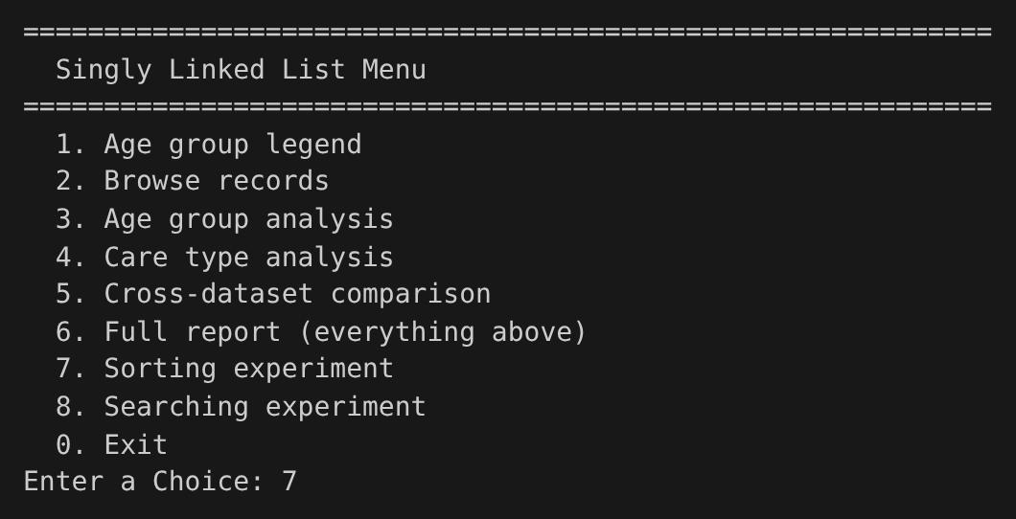
Figure 40: Linked List: Menu (Option 7) – INPUT
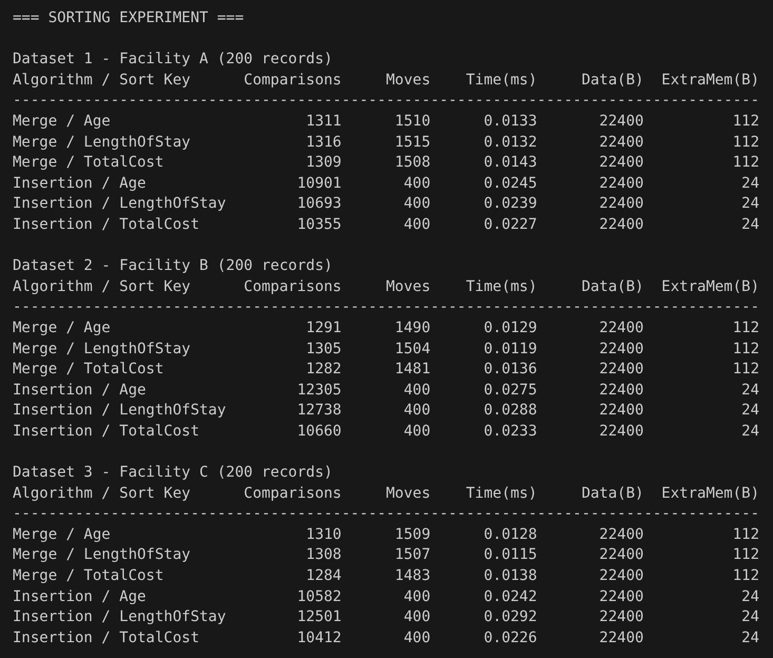
Figure 41: Linked List: Sorting Performance Results – OUTPUT
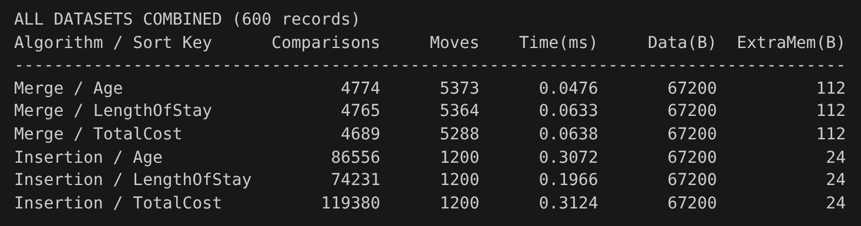
Figure 42: Linked List: Sorting Performance Results on Combined Dataset – OUTPUT

3.2.2.1 Merge Sort
As shown in Figure 41, merge sort needed 1,282 to 1,316 comparisons for each facility of 200 records and each run took about 0.012 to 0.014 ms. The number of comparisons is almost the same for all three sort keys because merge sort always splits the list in half no matter how the data is ordered. Merge sort made 1,481 to 1,515 moves, since the nodes are relinked again at every level of merging. The data size is 22,400 bytes (200 nodes x 112 bytes) and the extra memory is only 112 bytes for the stub node.
For the combined list of 600 records (Figure 42), merge sort needed 4,689 to 4,774 comparisons and 5,288 to 5,373 moves, and took about 0.05 to 0.06 ms. Tripling the list size raised the comparisons by about 3.6 times, which fits the O(n log n) growth of merge sort. The data size went up to 67,200 bytes, but the extra memory stayed at 112 bytes.

3.2.2.2 Insertion Sort
As shown in Figure 41, insertion sort needed 10,355 to 12,738 comparisons for each facility, which is about eight to ten times more than merge sort, and took about 0.023 to 0.029 ms. The number changes with the sort key because insertion sort depends on how close the data already is to the sorted order. On the other hand, insertion sort only made 400 moves, as each node only needs two pointer changes to be inserted. The extra memory is just 24 bytes for three pointers.
For the combined list (Figure 42), insertion sort needed 74,231 to 119,380 comparisons and took up to 0.31 ms. Merge sort needed about 16 to 25 times fewer comparisons and was about 3 to 6.5 times faster. Tripling the list size increased the comparisons by about 7 to 12 times, which shows the O(n²) growth of insertion sort. Even though insertion sort has fewer moves, merge sort is the better choice for the linked list as the number of records grows.

3.3 Searching
The option 10 of the array program and option 7 of the linked list program perform the searching experiments on Facility A, Facility B, Facility C and the combined data set.

3.3.1 Array

3.3.1.1 Linear Search
Linear search is performed on the original data set. Each record or node is examined, so that the number of comparisons is equal to the number of records, regardless of any matches.
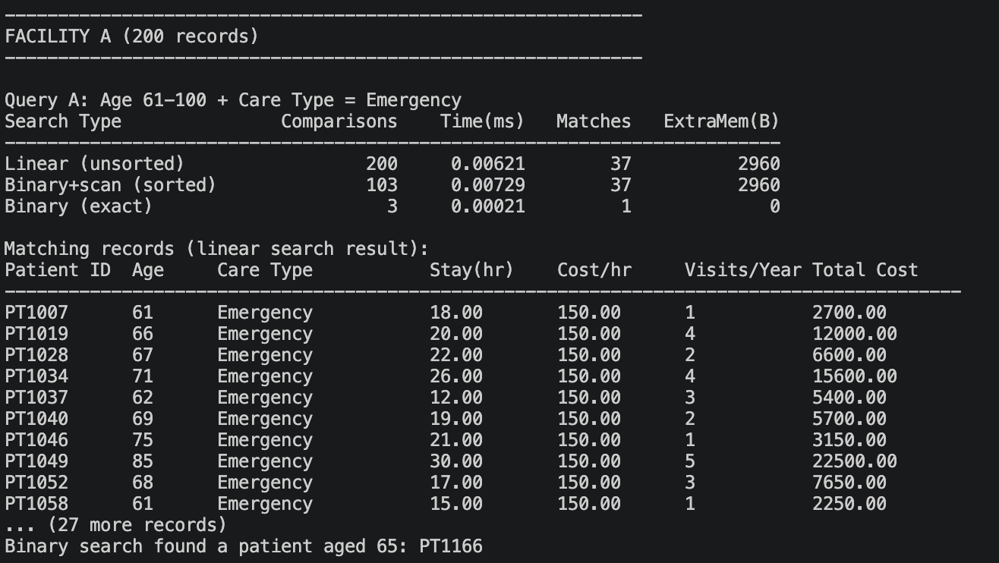
Figure 43: Query A on Facility A (Array)
Linear search on Facility A found 37 matches after examining all 200 records, taking 0.00621 ms.
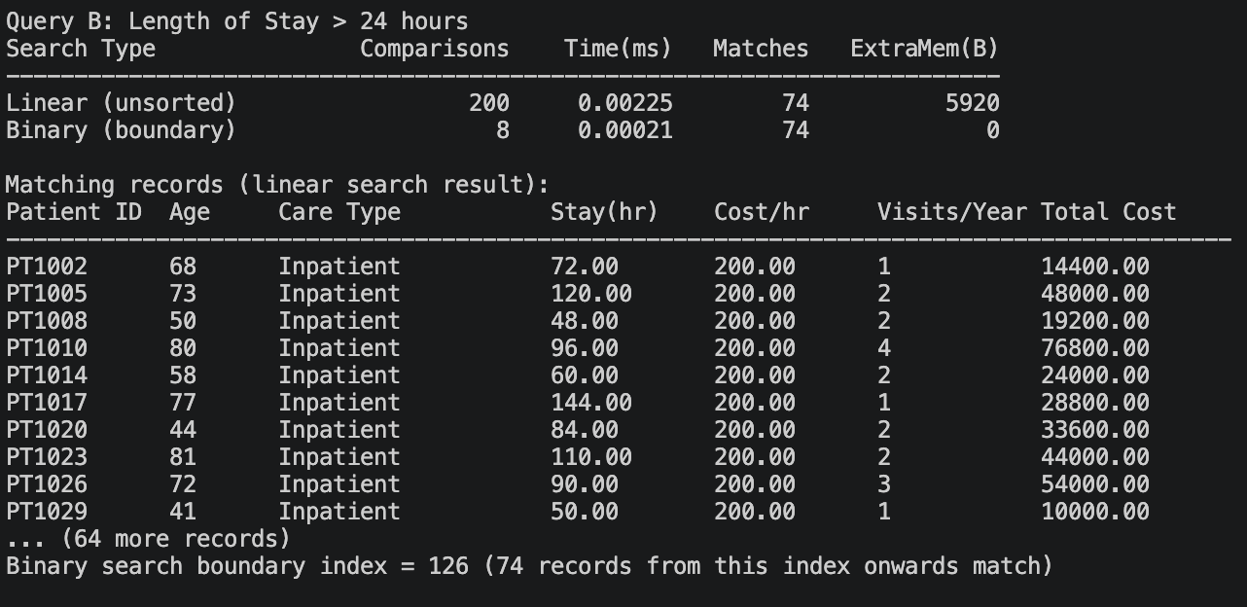
Figure 44: Query B on Facility A (Array)
Linear search on Facility A found 74 matches after 200 comparisons, completed in 0.00225 ms.

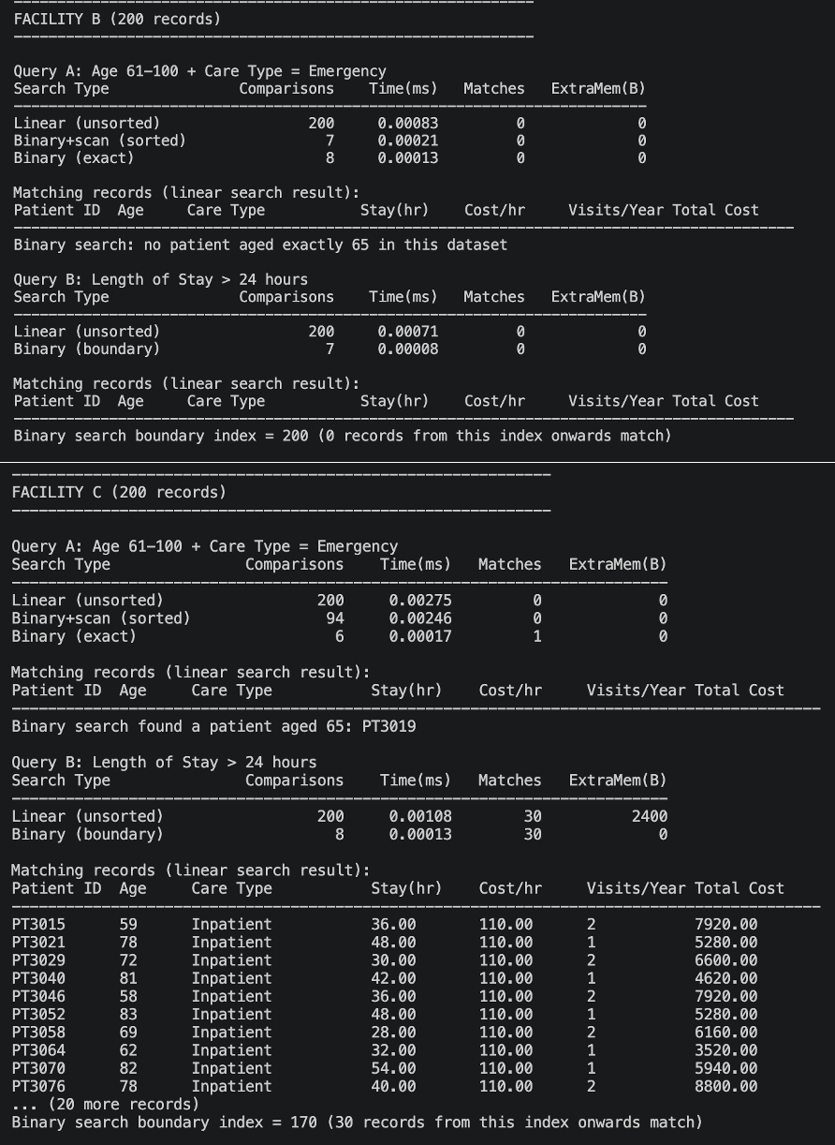
Figure 45: Query A and Query B on Facility B and Facility C (Array)
Facility B retrieved no matches for both queries (200 comparisons each). The Facility C retrieved no matches for Query A and 30 matches for Query B (each required 200 comparison.

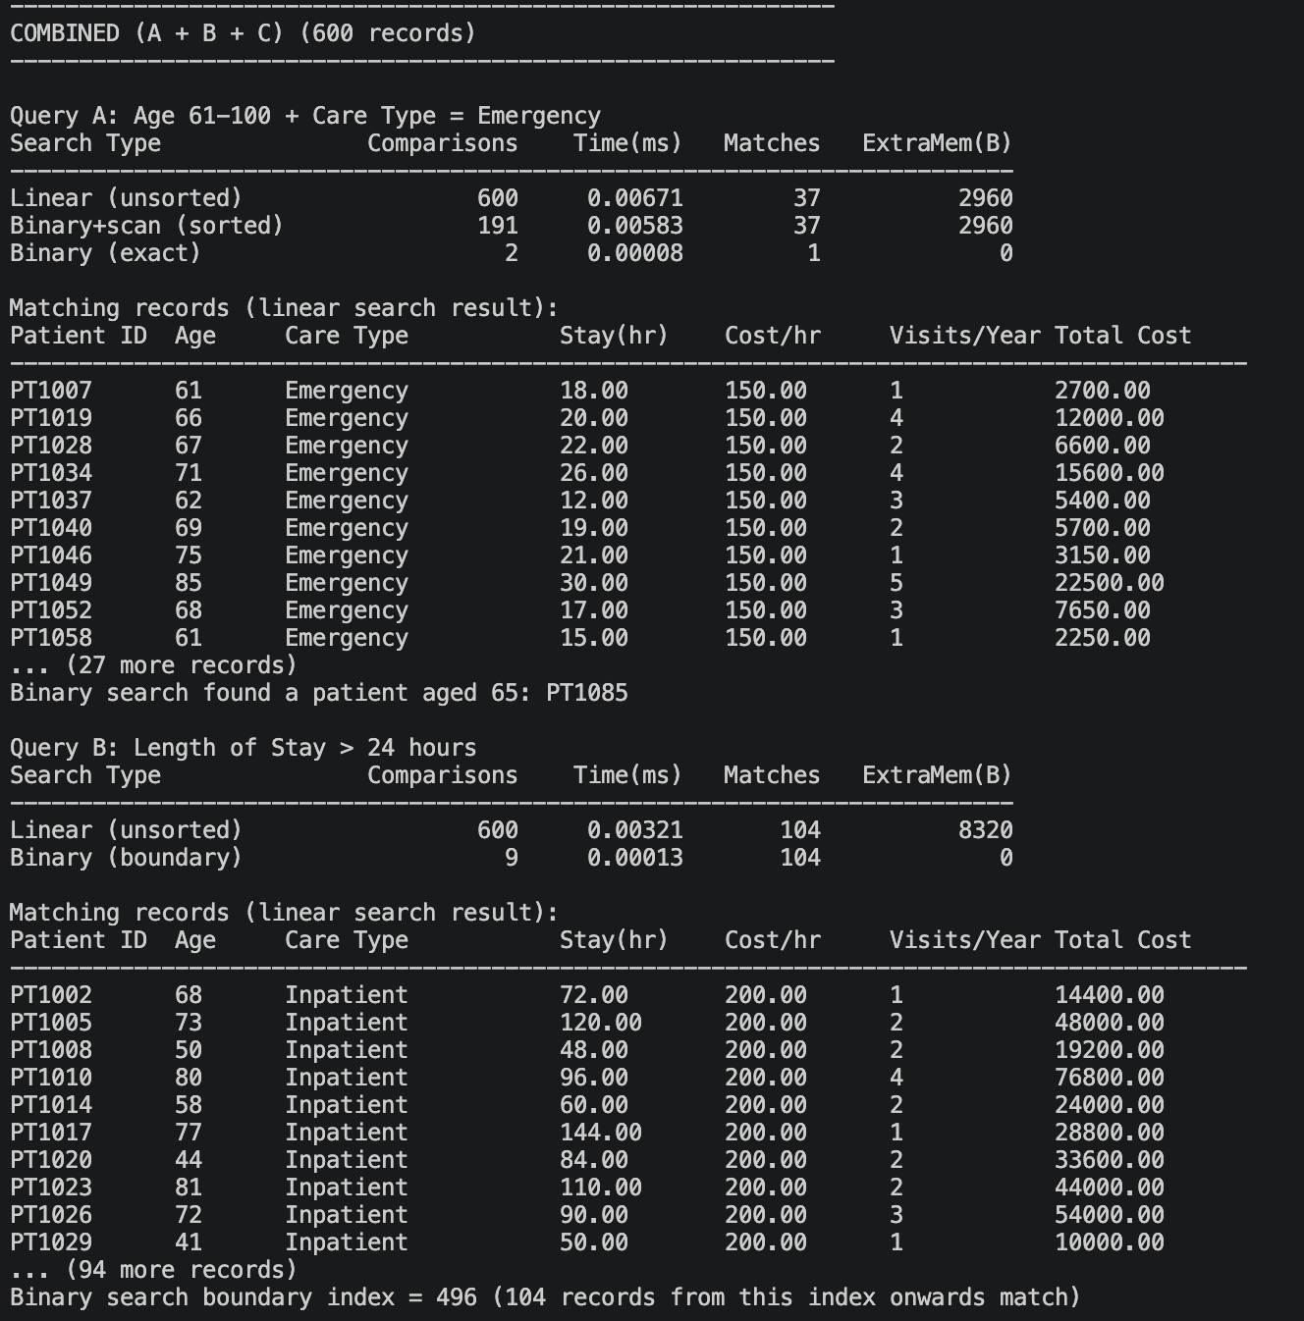
Figure 46: Query A and Query B on Combined Dataset (Array)
On the combined dataset of 600 items, the linear search algorithm performed 600 comparisons for both queries and found 37 and 104 matches for Query A and Query B respectfully.
Both the array and the linked-list required the same amount of comparisons for the unsorted data. Facilities B and C have no Emergency patients aged 61 to 100, but a full traversal was needed.

The binary search is performed on a copy sorted by the age (Query A and exact search) or length of stay (Query B), the sort time not being counted in the search time.
Figure 47: Query A on Facility A
Binary search on the age-sorted copy of Facility A found 37 matches after 200 comparisons (binary phase + range scan) in 0.00729 ms
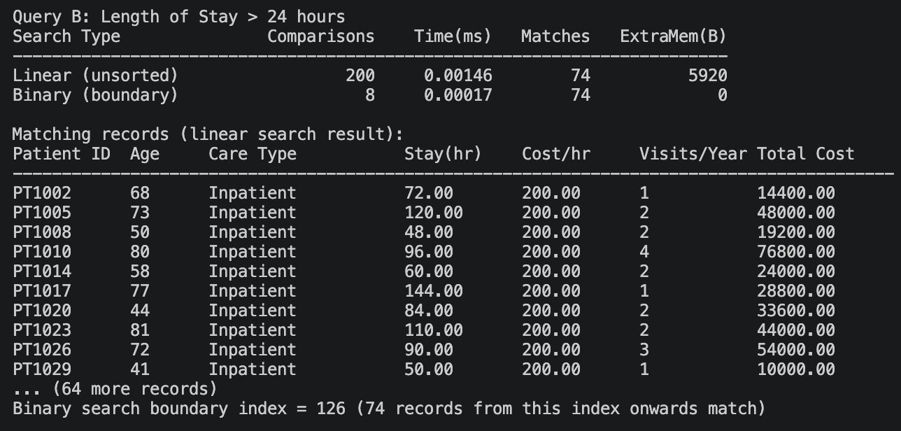
Figure 48: Query B on Facility A
Binary search on the length-of-stay-sorted copy found 74 matches after 200 comparisons in 0.00017 ms
Figure 49: Binary rows for Facility B and Facility C
According to figure above, Query A, 7 comparisons (exact search 8, without patient aged 65); Query B, 7 comparisons, boundary index 200. C: Query A, 94 comparisons, exact search 6 (PT3019); Query B, 8 comparisons, boundary index 170
Figure 50: Binary Search on Combined Dataset
On the combined data set, Query A took 191 comparisons (binary search phase plus scanning the matching range) while an exact search for age 65 located patient PT1085 in 2 comparisons. Query B took 9 comparisons with boundary index of 496, retrieving 104 matches. Binary search is applied to a sorted copy of the data (sorted by age for Query A and by length of stay for Query B) and the time required to sort is not included in the reported search time.

3.3.2 Linked List
Option 8 of the linked list program runs the searching experiment on Facility A, Facility B, Facility C and the combined dataset. Two queries are used: senior emergency patients (age 61 to 100 with care type Emergency) and long stay patients (visit duration more than 24 hours). Each query is run with linear search on the unsorted list and with binary search on the sorted list.
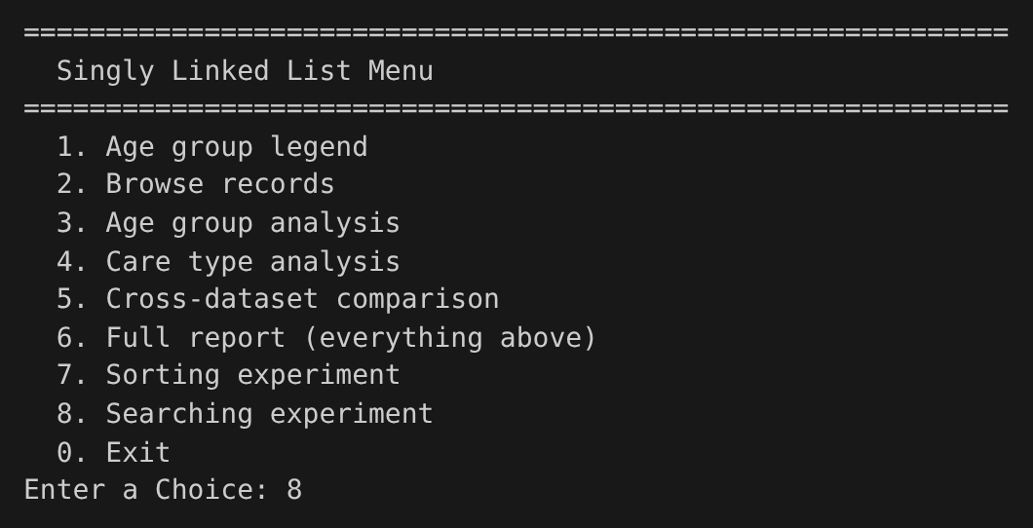
Figure 51: Linked List: Menu (Option 8) – INPUT
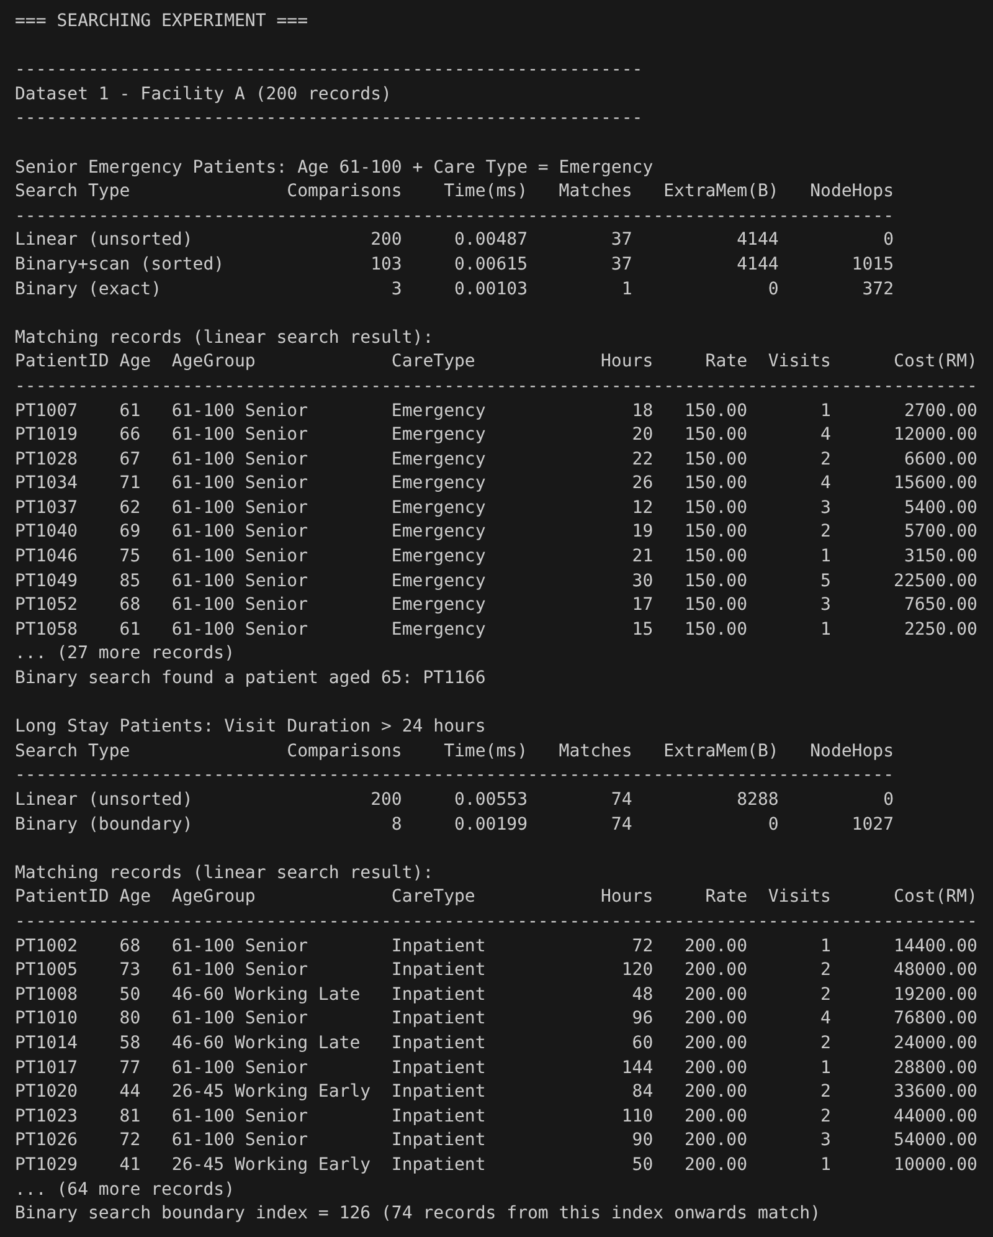
Figure 52: Linked List: Searching Results on Facility A – OUTPUT
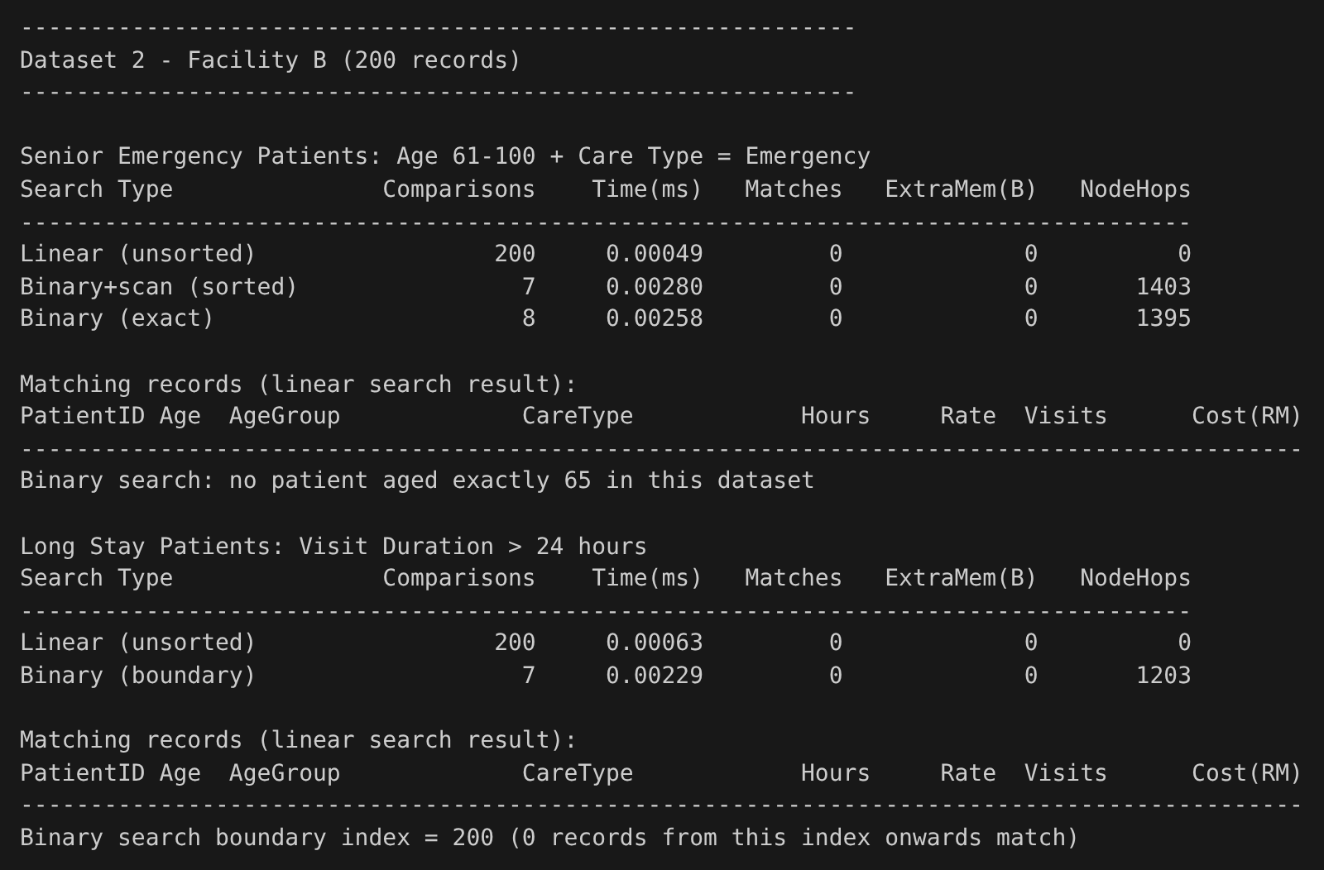
Figure 53: Linked List: Searching Results on Facility B – OUTPUT
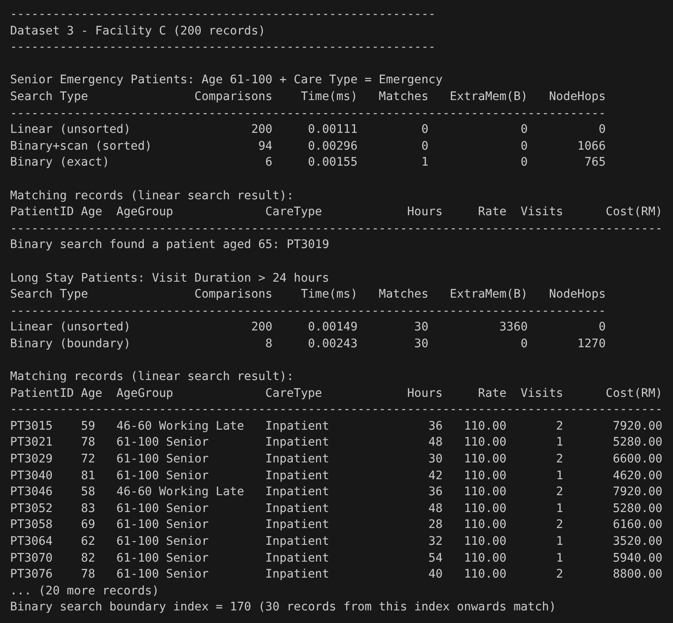
Figure 54: Linked List: Searching Results on Facility C – OUTPUT
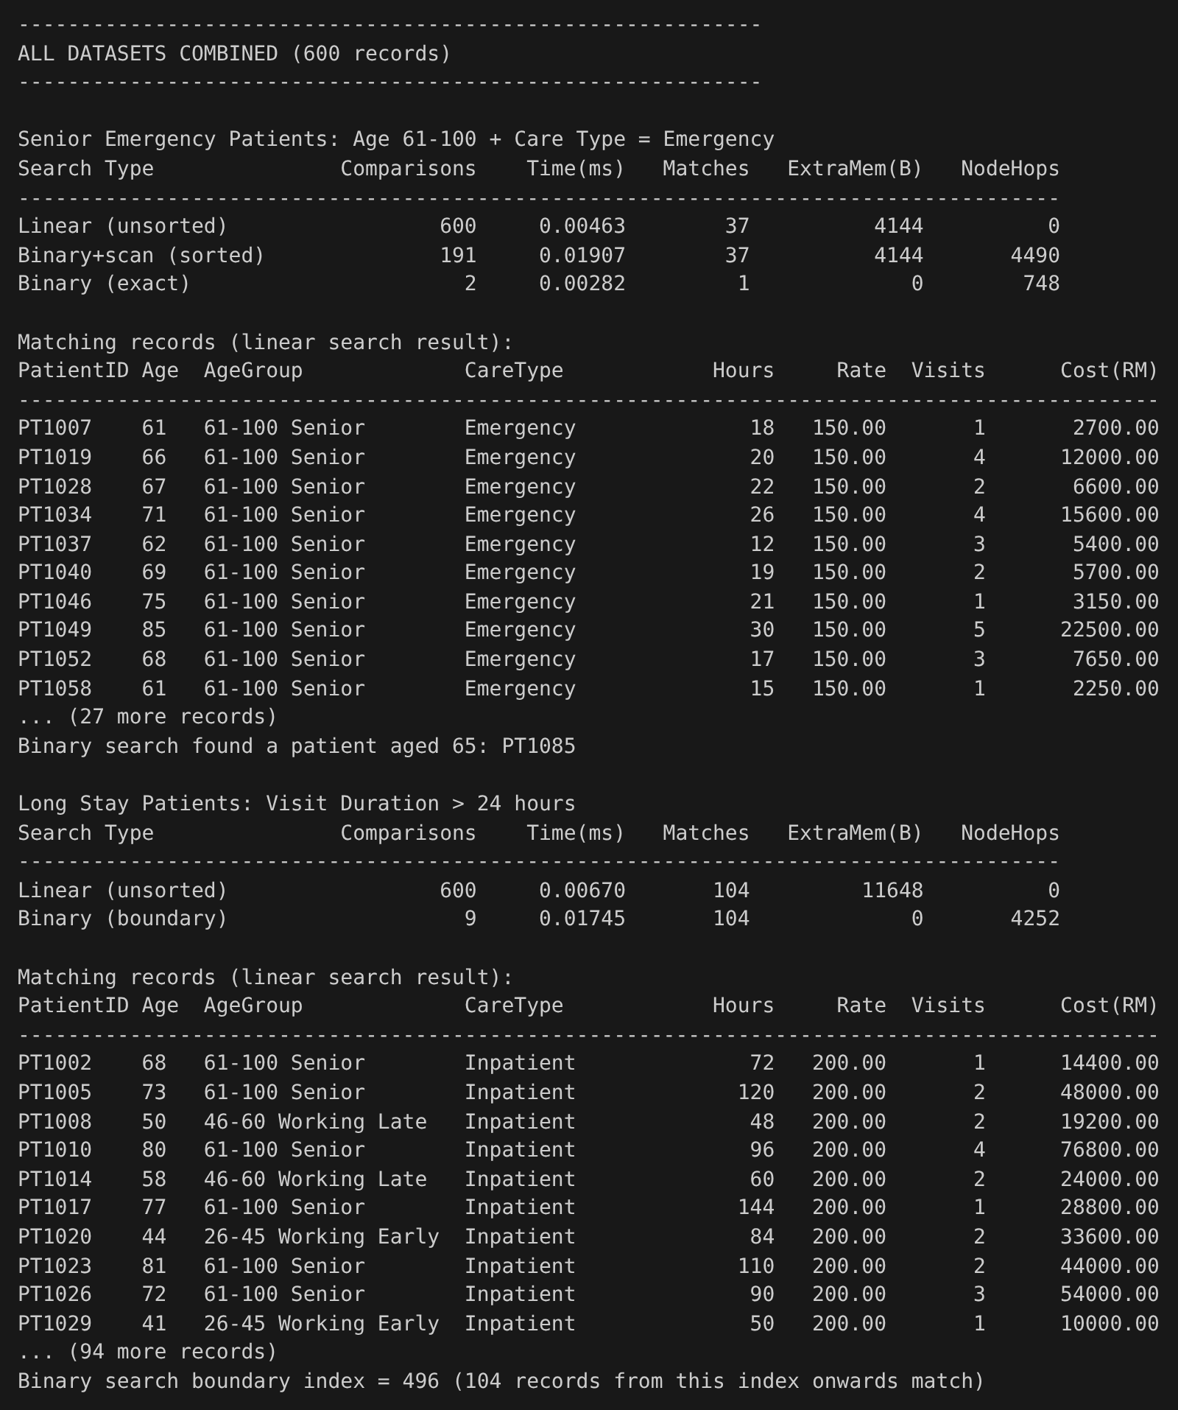
Figure 55: Linked List: Searching Results on Combined Dataset – OUTPUT

3.3.2.1 Linear Search
Linear search is done on the list in its original patient ID order. Every node is visited, so the number of comparisons is always equal to the number of records, whether there are matches or not, and the node hops stay at 0.
As shown in Figure 52, linear search on Facility A found 37 senior emergency patients after 200 comparisons in 0.00487 ms, and 74 long stay patients after 200 comparisons in 0.00553 ms. The extra memory is 4,144 bytes and 8,288 bytes, which is the number of matches times 112 bytes for each node in the results list.
Facility B (Figure 53) returned no matches for both queries, and Facility C (Figure 54) returned no senior emergency patients but 30 long stay patients (3,360 bytes). All of these searches still needed 200 comparisons, because linear search has to visit every node before it can confirm there are no more matches.
On the combined dataset of 600 records (Figure 55), linear search made 600 comparisons for both queries and found 37 and 104 matches in 0.00463 ms and 0.00670 ms. Tripling the list size tripled the comparisons, which shows the O(n) growth of linear search. These comparison counts are the same as the array version, since both scan every record once.

3.3.2.2 Binary Search
Binary search is done on a list that is first sorted by age (senior emergency and exact search) or by length of stay (long stay), and the sorting time is not counted in the search time.
As shown in Figure 52, the range search on Facility A found the same 37 senior emergency patients with only 103 comparisons, and the exact search found a patient aged 65 (PT1166) in 3 comparisons. The boundary search found the 74 long stay patients with only 8 comparisons, with the boundary at index 126. However, these searches needed 1,015, 372 and 1,027 node hops, because the program has to walk from the head to every middle point. Because of this, the range search (0.00615 ms) was actually slower than the linear search (0.00487 ms).
For Facility B (Figure 53), the range search needed 7 comparisons, the exact search 8 comparisons with no patient aged 65, and the boundary search 7 comparisons with the boundary at index 200, which means no patient stayed more than 24 hours. Even with so few comparisons, they needed 1,403, 1,395 and 1,203 node hops and took longer than the linear search. Facility C (Figure 54) needed 94 comparisons for the range search, 6 for the exact search (PT3019) and 8 for the boundary search, which found the same 30 long stay patients from index 170.
On the combined dataset (Figure 55), the range search needed 191 comparisons and the exact search found PT1085 in 2 comparisons, while the boundary search needed only 9 comparisons to find 104 long stay patients from index 496. These comparisons are the same as the array version, but the linked list also needed 4,490 and 4,252 node hops, and the range and boundary searches took 0.01907 ms and 0.01745 ms, about 2.5 to 4 times slower than linear search. This shows that binary search reduces the comparisons but not the steps needed to reach the nodes on a singly linked list, so it works much better on an array where the middle element can be reached directly.

4.0 Individual Part

4.1 Ian Chin Jun Sheng

4.1.1 Responsibilities and Contribution

4.1.2 Functions / Components Developed

4.1.3 Implementation Decisions

4.1.4 Analysis

4.2 Isac Lim Yong Hao

4.2.1 Responsibilities and Contribution
I was responsible for the searching module of the array program (Searchanalysis.hpp). It included the search criteria structure, linear search of the unsorted array, binary search of the sorted array (boundary, range, and exact search), measuring the number of comparisons, time, and extra memory consumption, and outputting the results in console tables. In addition, I was responsible for the Workload Matrix and sections 2.4, 3.3, 4.2, and 5.2 of this report.

4.2.2 Functions / Components Developed
Function | Purpose
getAgeGroupIndex() | Maps a patient's age to one of the five age-group indices
collectAgeGroupStats() | Scans the array once and fills statistics for all five age groups
printAgeGroupReport() | Prints the formatted age group analysis table for one dataset
SearchCriteria, matchesCriteria() | Holds the query (age range, care type, stay threshold) and tests one record
linearSearch() | Full scan that collects all matches on unsorted data
binaryFirstGreater() | Binary search for the first index greater than a threshold
rangeSearchSortedByAge() | Binary search for the lower age bound, then a scan that filters care type
binarySearchByKey() | Exact-value binary search (age 65)
insertionSort() | Classic insertion sort with comparison & move counting
mergeSort() | Merge-sort implementation with temporary array and counters

4.2.3 Implementation Decisions
The searching module was designed around the single SearchCriteria structure that allows combining different search criteria, such as age range, care type, and stay threshold, in arbitrary ways, without writing multiple functions for each combination. The functions ageOf and stayOf utilize function pointers so that a single binary-search routine can search for patients by age and length of stay. Linear search runs to completion since the hospital needs all matching patients, not just the first one. For range queries, a binary search would yield only one result, so the implementation performs a boundary search followed by a linear scan to find all patients in the desired range. The midpoint is calculated in the overflow-safe way as low + (high – low) / 2. All searches run on a sorted copy of the original data to avoid modification of the original array. The number of comparisons is counted directly by placing a counter inside the loop. The extra memory is specified in terms of the number of elements, so for the searches that do not allocate an array for results (boundaries and exact match), this value is zero. The searching module uses the mergeSort function from Sortinganalysis.hpp (written by Ye Wen) to sort data by age and length of stay. No STL data structures are used; the results are stored in a C-style array for simplicity and consistency with the rest of the program’s array-based data storage.

4.2.4 Analysis
Linear search was always performed a number of comparisons equal to the dataset size (200 per facility, 600 for the combined data), regardless of the number of matches found. Binary search reduced the number of comparisons significantly. For Query B the boundary search required only 7–9 comparisons instead of 200 or 600. For Query A the range search required between 94 and 191 comparisons as the linear scan following the binary phase needs to examine every record that falls inside the age interval; thus, its running time remained close to that of the linear search. Exact searches for age 65 finished in only 2–8 comparisons.
All the measured execution times are on the order of a few thousandths of a millisecond. With only 200 records per facility and one run of each query, timing noise is relatively large; small differences between two timings should therefore not be interpreted as significant performance differences. The comparison counts are a more reliable metric.
Limitations. The data set is small; each timing figure is a single measurement; sorting time is not excluded from the search cost, so the advantage of binary search materialises when many queries reuse the same sorted copy; care type has no inherent order and can be filtered only by scanning; the extra-memory figure accounts only for the stored result set and does not include the temporary sorted copy of the array.

4.3 Lai Kerjinn

4.3.1 Responsibilities and Contribution

4.3.2 Functions / Components Developed

4.3.3 Implementation Decisions

4.3.4 Analysis

4.4 Mohamed Muhlis

4.4.1 Responsibilities and Contribution

4.4.2 Functions / Components Developed

4.4.3 Implementation Decisions

4.4.4 Analysis

4.5 Soh Ye Wen

4.5.1 Responsibilities and Contribution

4.5.2 Functions / Components Developed

4.5.3 Implementation Decisions

4.5.4 Analysis

5. Experimental Results and Overall Comparative Analysis

5.1 Overall Sorting Comparison

5.2 Overall Searching Comparison

5.3 Performance Analysis

5.3.1 Execution Time Analysis

5.3.2 Memory Footprint Analysis

5.3.3 Conditions Where Each Structure Performs Better

5.3.4 Real-World Advantages and Trade-offs

5.4 Overall Array vs Linked List Findings

5.5 Strengths and Limitations

6. Clinical Insights and Recommendations

6.1 Treatment Cost and Service Preference Analysis

6.2 Highest Healthcare Billing by Demographic Group

6.3 Highest Patient Traffic by Care Type

6.4 Recommendations for Hospital Administrators

5.0 Conclusion

6.0 References

7.0 Workload Matrix
Names | Tasks | Signatures
Ian Chin Jun Sheng | Introduction  Data Description  Singly Linked List Implementation | Ian
Isac Lim Yong Hao | Sorting Method (Array)  Searching Method (Array) | Isac
Lai Ker Jinn | Array Implementation | Lai
Mohamed Muhlis | Healthcare Analysis  Integration | Muhlis
Soh Ye Wen | Sorting Method (Linked List)  Searching Method (Linked List)  Conclusion | Ye Wen

8.0 Appendix

